**EXPERIMENT – 1**

**AIM:**

To perform various commands given in SQL in Oracle

**Procedure**:

1) Open SQL 8.0 tool and it will display the login window.

2) Enter the username = ‘SCOTT’ and password = ‘TIGER’

3) After the successfully login try to write down the SQL queries in correct syntax and run them successfully.

**OUTPUT:**

**1, TABLE CREATION:**

**SQL> CREATE TABLE EMPLOYEEDB(ID NUMBER(5),NAME VARCHAR2(15),CONTACT NUMBER(10),SALARY NUMBER(10));**

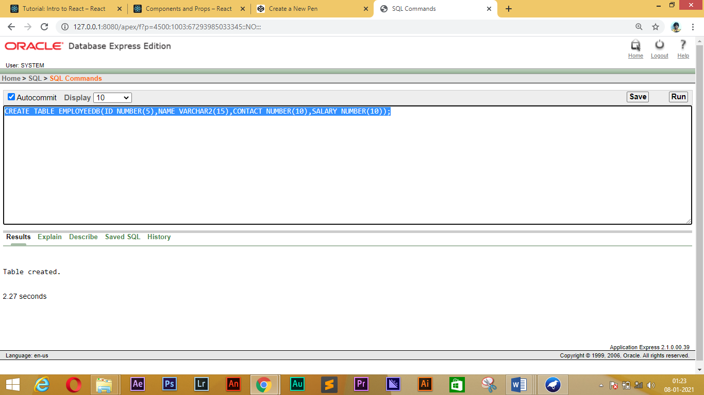

**2, ROW INSERTON:**

**SQL>** **INSERT INTO EMPLOYEEDB VALUES(101,'AARTHI',8637483834,10000);**

**SQL>** **INSERT INTO EMPLOYEEDB VALUES(102,'MONI',8634547219,8000);**

**SQL>** **INSERT INTO EMPLOYEEDB VALUES(103,'ACHU',7657653489,15000);**

**SQL>** **INSERT INTO EMPLOYEEDB VALUES(104,'JAMUNA',7657688654,20000);**

**SQL>** **INSERT INTO EMPLOYEEDB VALUES(105,'IYAPPAN',798783489,15000);**



**3, SELECT COMMAND:**

**SQL> SELECT * FROM EMPLOYEEDB**

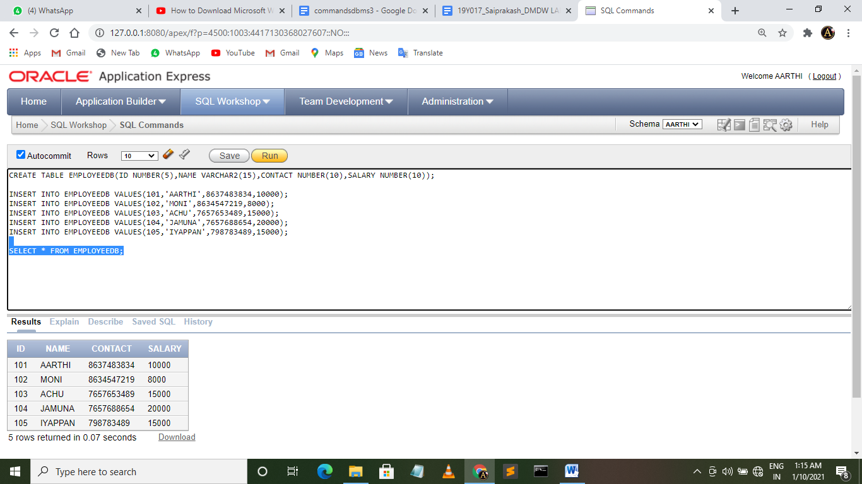

**4, UPDATE COMMAND:**

**SQL>** **UPDATE EMPLOYEEDB SET NAME='ABI' WHERE ID=101**



**5,TABLE ALTERATION:**

**SQL>** **ALTER TABLE EMPLOYEEDB MODIFY NAME VARCHAR2(20)**



**6, SELECT EMPLOYEE DETAILS WHERE ID=101:**

**SQL>** **SELECT * FROM EMPLOYEEDB WHERE ID=101**

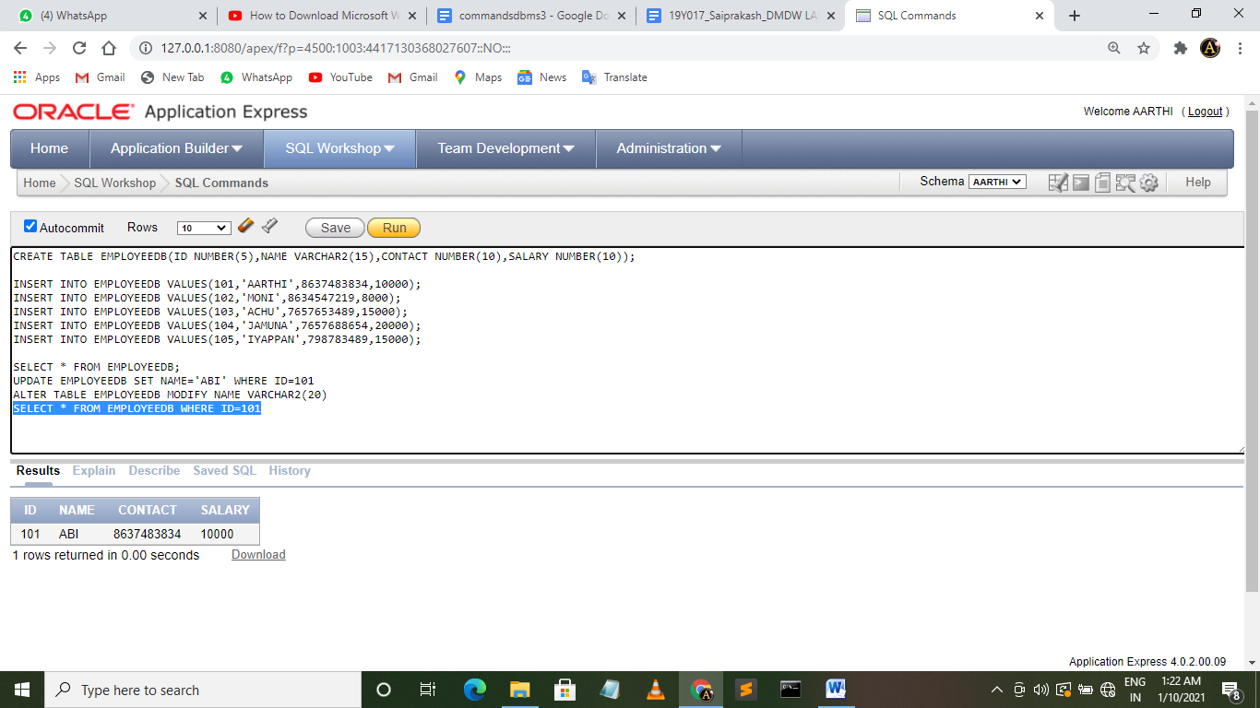

**7, DISPLAY EMPLOYEES NAME WHOSE SALARY IS MORE THAN 10000:**

**SQL>** **SELECT NAME FROM EMPLOYEEDB WHERE SALARY>10000**

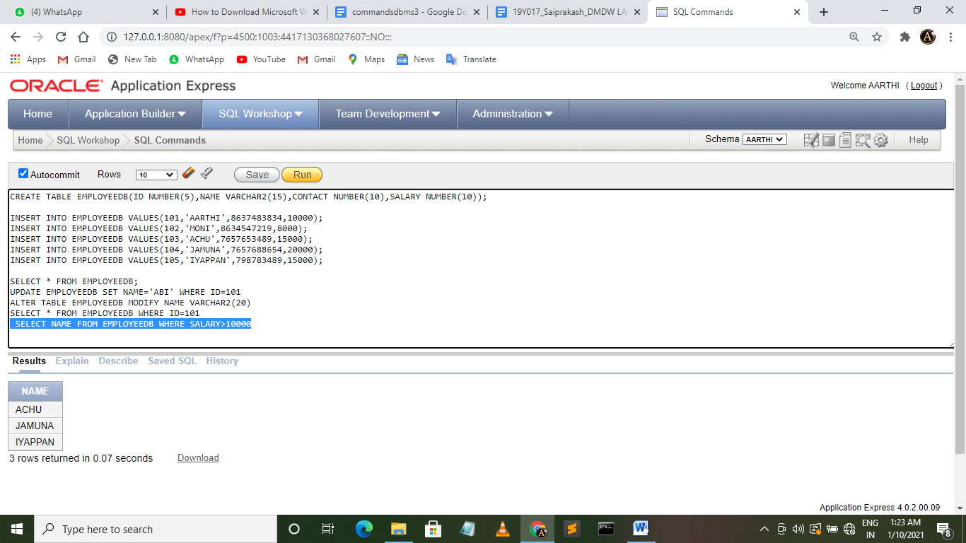

**8, SELECT ALL NAMES IN EMPLOYEEDB TABLE THAT STARTS WITH LETTER ‘A’:**

**SQL> SELECT NAME FROM EMPLOYEEDB WHERE NAME LIKE 'A%'**

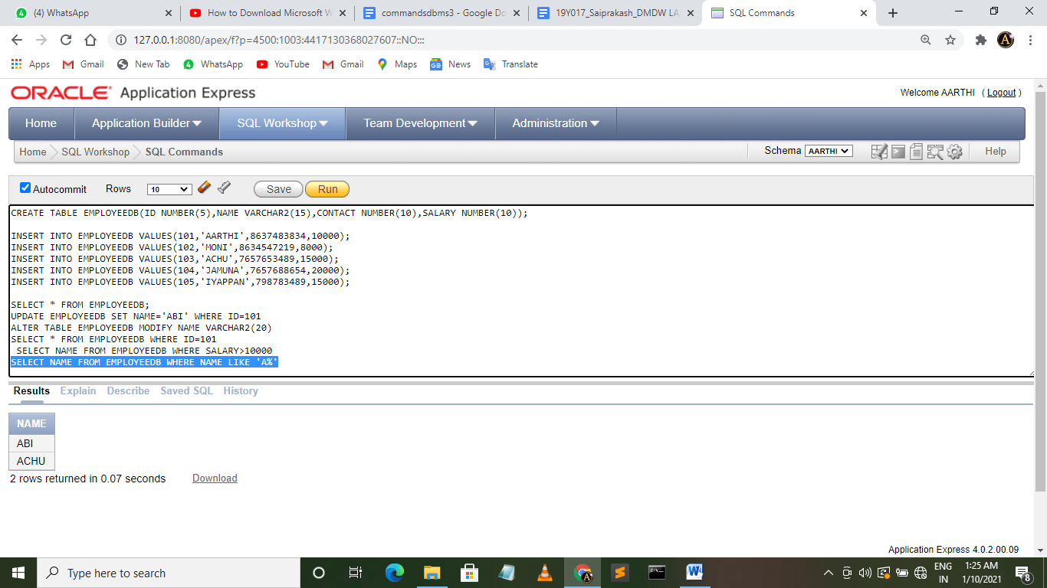

**9, ORDER BY USING SALARY:**

**SQL> SELECT NAME, CONTACT, SALARY FROM EMPLOYEEDB ORDER BY SALARY**

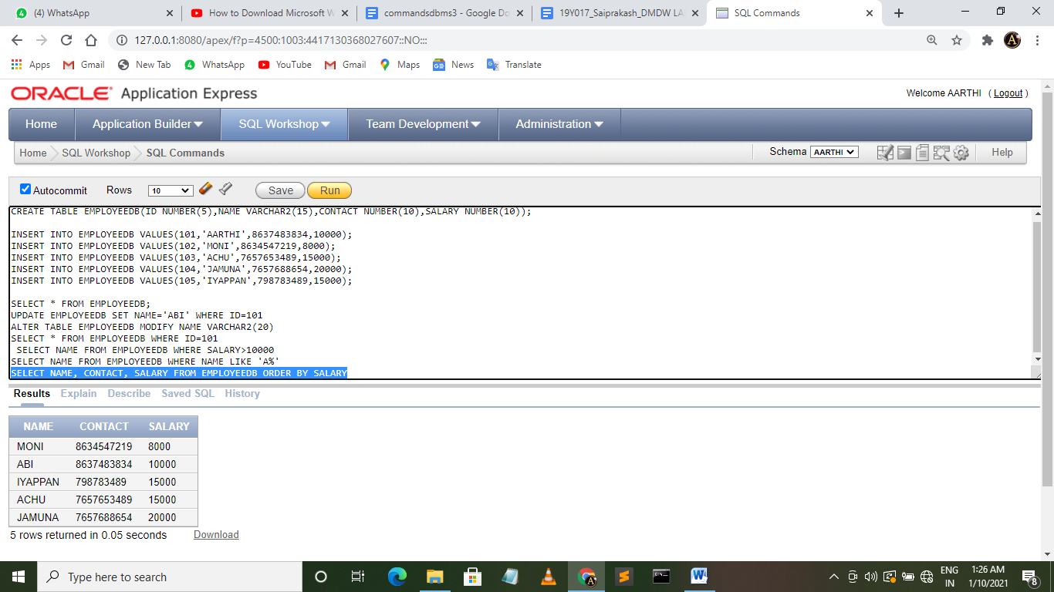

**10, DISPLAY THE EMPLOYEE WHO HAS THE HIGHEST SALARY**

**SQL> SELECT NAME FROM EMPLOYEEDB WHERE SALARY IN ( SELECT MAX(SALARY) FROM(SELECT SALARY FRO EMPLOYEEDB))**

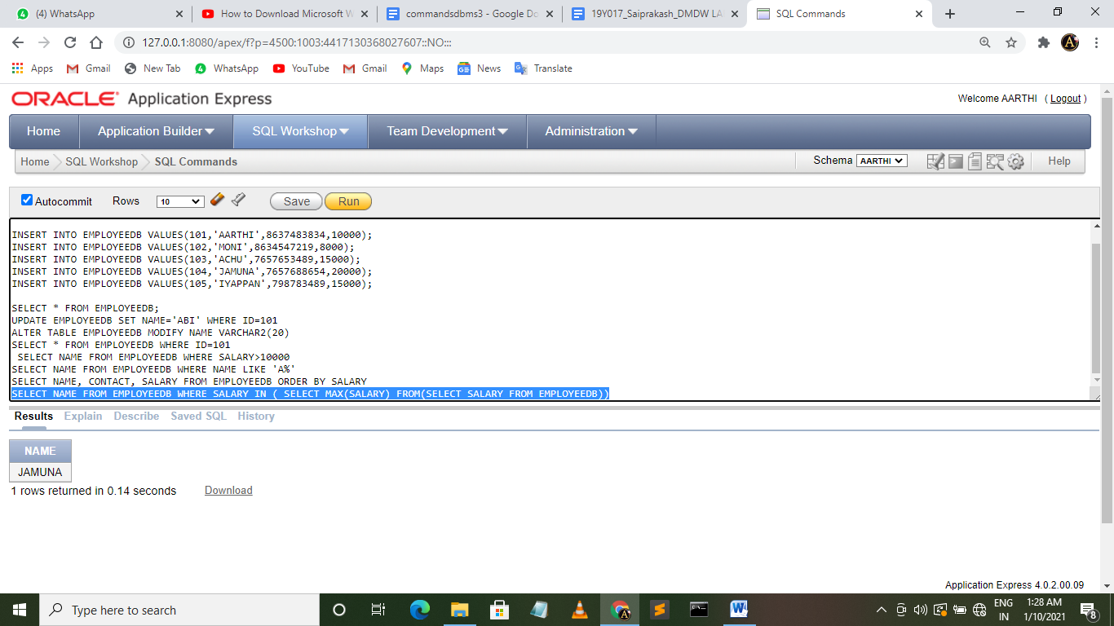

**RESULT:**

All the SQL commands are executed successfully.

**Experiment – 2**

**Aim:**

To perform multi-dimensional data model using SQL queries. E.g. Star, snowflake and Fact constellation schemas.

**Tools/ Apparatus**:

Oracle 8i/9i/10G

**Procedure:**

1) Open Oracle 8i/9i/10G tool and it will display the login window where one has to enter the login details.

2) Create the fact and the required dimensions tables as per the given business problem. There are three basic types of the multidimensional data model. They are Star, snowflake and Fact constellation schemas

3) As per the guidelines given in the theory draw all the three dimensional models.

Use the following queries : Define cube sales_star[time, item, branch, location];

Dollars_sold = sum(sales_in_dollars), units_sold = count(*).

Define dimension time as(time_key,day,day_of_week, month, quarter, year).

Write the same queries for all other dimensions resp. Then run the following query:

Select s.time_key,s.item_key, s..branch_key, s.location_key,

Sum(s.number_of_units_sold*s.price), sum(s.number_of_units_sold)

From time t,item I, branch b, location l, sales s,

Where s.time_key = t.time_key and s.item_key = i.item_key and s.branch_key =

b.branch_key and s.location_key = l.location_key

Group by s.time_key, s.item_key, s.branch_key, s.location_key.

Run the queries to create the various multi-dimensional models.

**Output:**

SQL> CREATE TABLE TIME(TIME_KEY NUMBER(5) PRIMARY KEY,DAY NUMBER(2),DAY_WEEK VARCHAR2(10),MONTH NUMBER(2),YEAR NUMBER(4));

SQL> CREATE TABLE ITEM(ITEM_KEY NUMBER(5) PRIMARY KEY,ITEM_NAME VARCHAR2(20),BRAND_KEY NUMBER(6));

SQL> CREATE TABLE BRANCH(BRANCH_KEY NUMBER(5) PRIMARY KEY,BRANCH_NAME VARCHAR2(20),EMPLOYEE_KEY NUMBER(6));

SQL> CREATE TABLE LOCATION(LOCATION_KEY NUMBER(5) PRIMARY KEY,STREET_NAME VARCHAR2(20),CITY_NAME VARCHAR2(20));

SQL> CREATE TABLE CUSTOMER(CUSTOMER_KEY NUMBER(5) PRIMARY KEY,CUSTOMER_NAME VARCHAR2(20),CONTACT VARCHAR2(20));

SQL> CREATE TABLE BRAND(BRAND_KEY NUMBER(6) PRIMARY KEY,BRAND_NAME VARCHAR2(20));

SQL> CREATE TABLE EMPLOYEE(EMPLOYEE_KEY NUMBER(5) PRIMARY KEY,NO_OF_EMP NUMBER(3),BRANCH_MANAGER VARCHAR2(20));

SQL> CREATE TABLE SALES(TIME_KEY NUMBER(5),ITEM_KEY NUMBER(5),BRANCH_KEY NUMBER(5),LOCATION_KEY NUMBER(5),DOLLARS_SOLD NUMBER(10),UNITS_SOLD NUMBER(5));

SQL> CREATE TABLE SALES_RETURNS(ITEM_KEY NUMBER(5),BRANCH_KEY NUMBER(5),CUSTOMER_KEY NUMBER(5),NO_OF_ITEMS_RETURNED NUMBER(10));

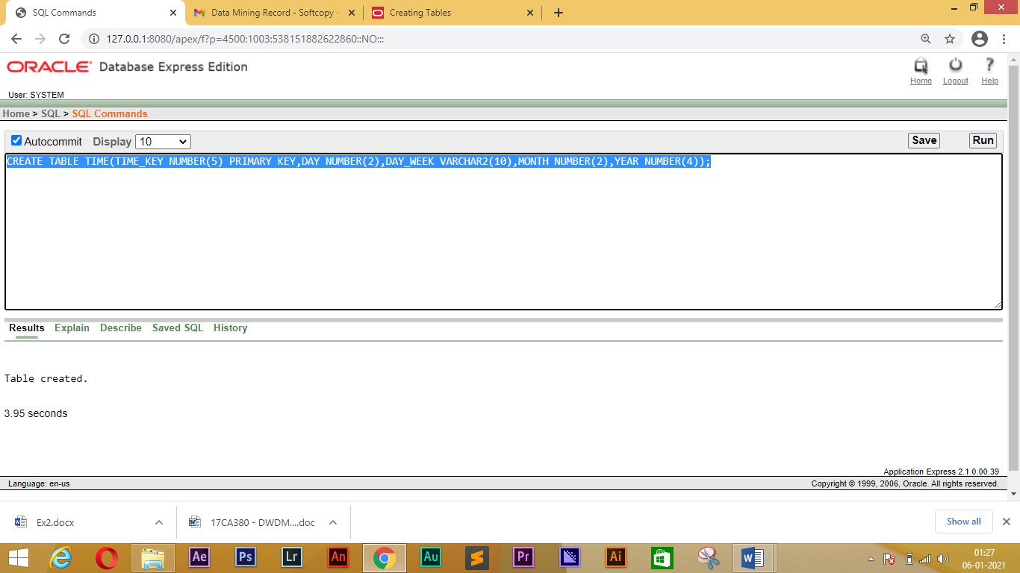

**STAR SCHEMA:**

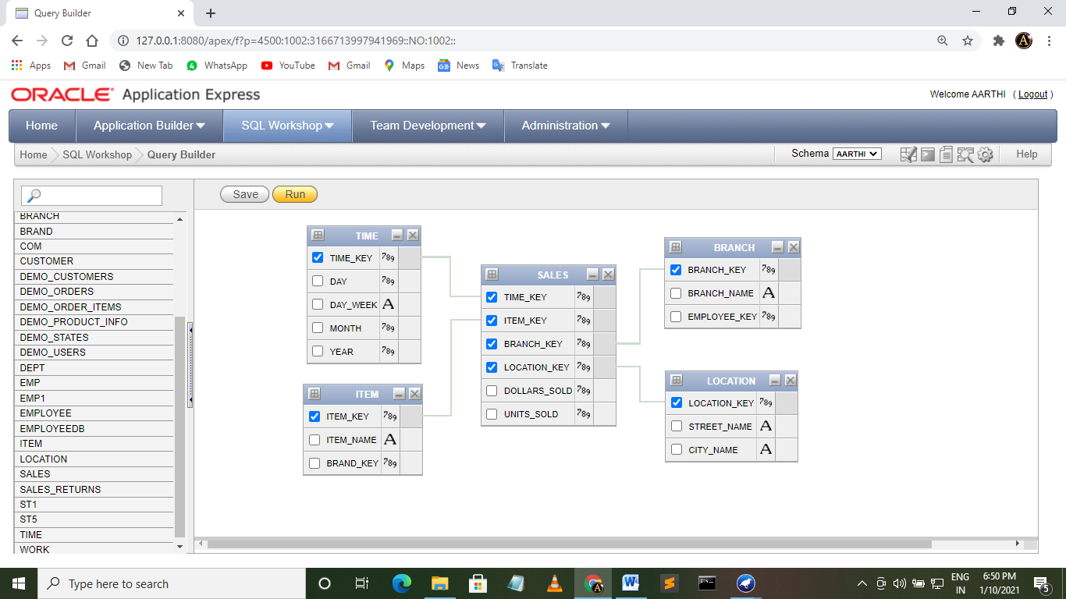

**SNOWFLAKE SCHEMA:**

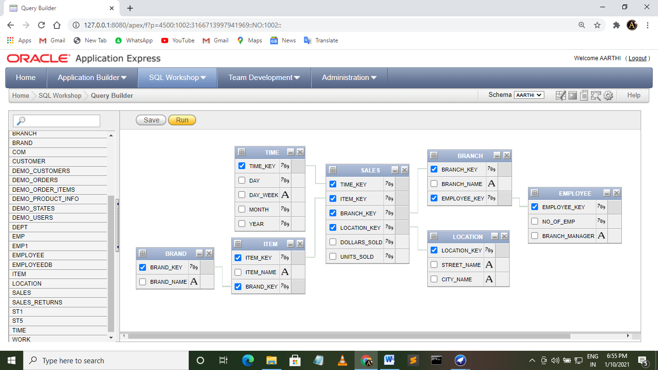

**FACT CONSTELLATION SCHEMA:**

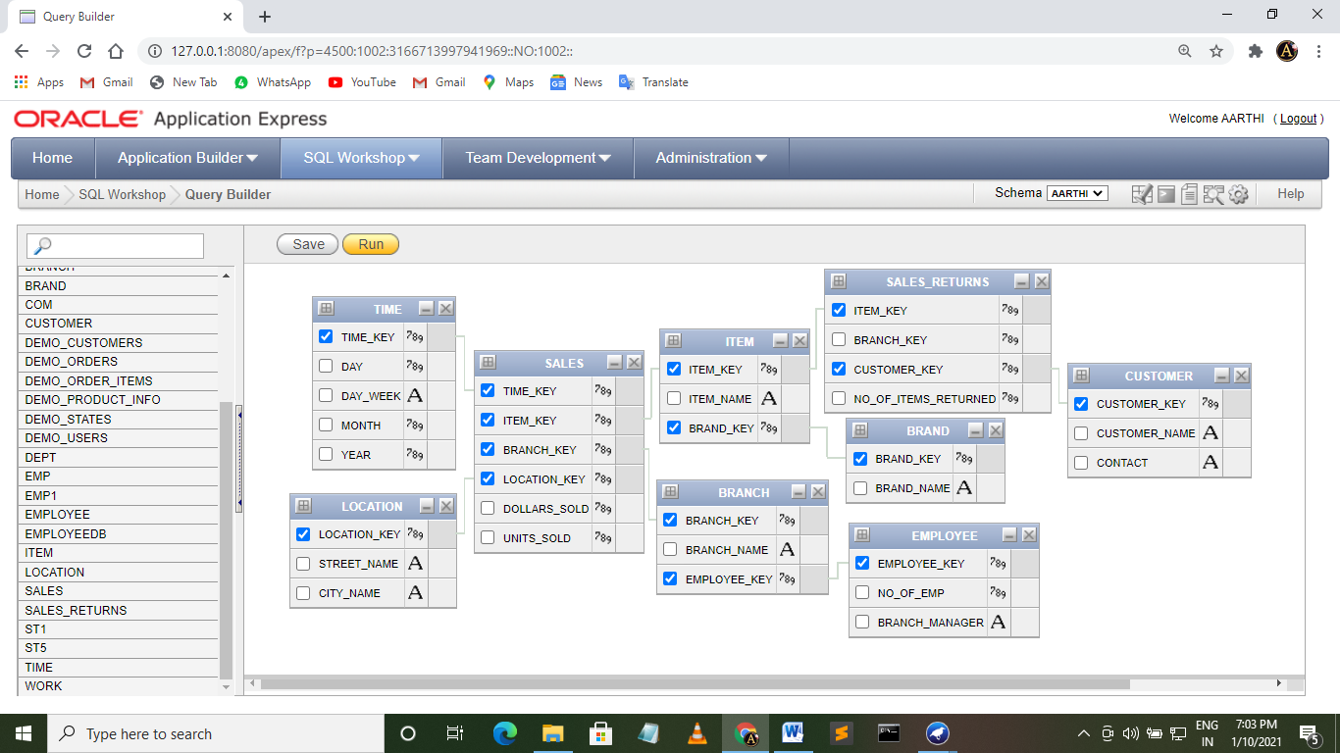

**RESULT:**

Multi-dimensional data model using SQL queries. E.g. Star, snowflake and Fact constellation schemas is made successfully.

**EXPERIMENT – 3**

**AIM:**

To perform various OLAP operations such slice, dice, roll up, drill up, pivot etc.

**Tools/ Apparatus**:

Oracle 8i/9i/10G, PL/SQL.

**Procedure:**

1) Open SQL tool and login successfully.

2) Write down the queries to perform slice. In which one should keep one of the

dimensions as constant and other dimensions should range from min to max.

3) Write down the queries to perform the dice. In which one has to keep two of the

dimensions constant.

4) Write down the queries to perform roll-up by keeping one dimension constant and others should range from min to max. It is more like a generalization.

5) Write down the queries to perform roll-up by keeping one dimension constant and others should range from min to max. It is more like a specialization.

**OUTPUT:**

**ROLLUP:**

**SQL> SELECT ID, SUM(SALES) FROM PRODUCT GROUP BY ROLLUP(ID) ORDER BY ID**

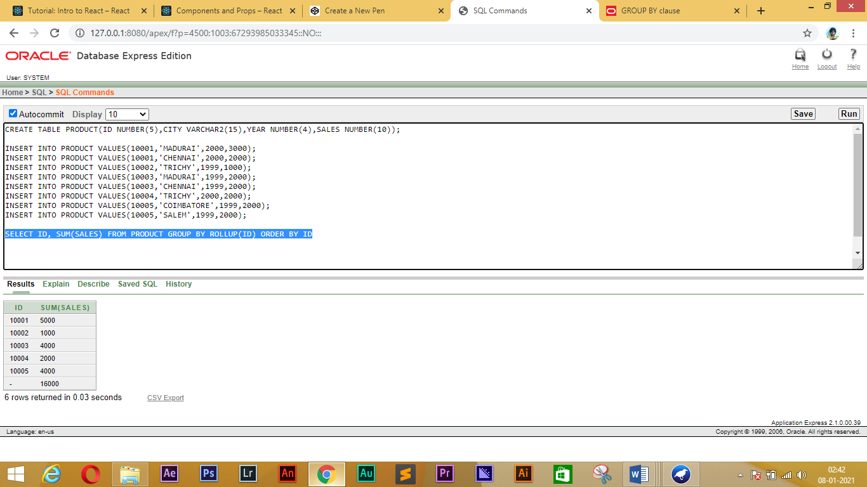

**DRILL DOWN:**

**SQL> SELECT ID, CITY, SALES FROM PRODUCT ORDER BY YEAR**

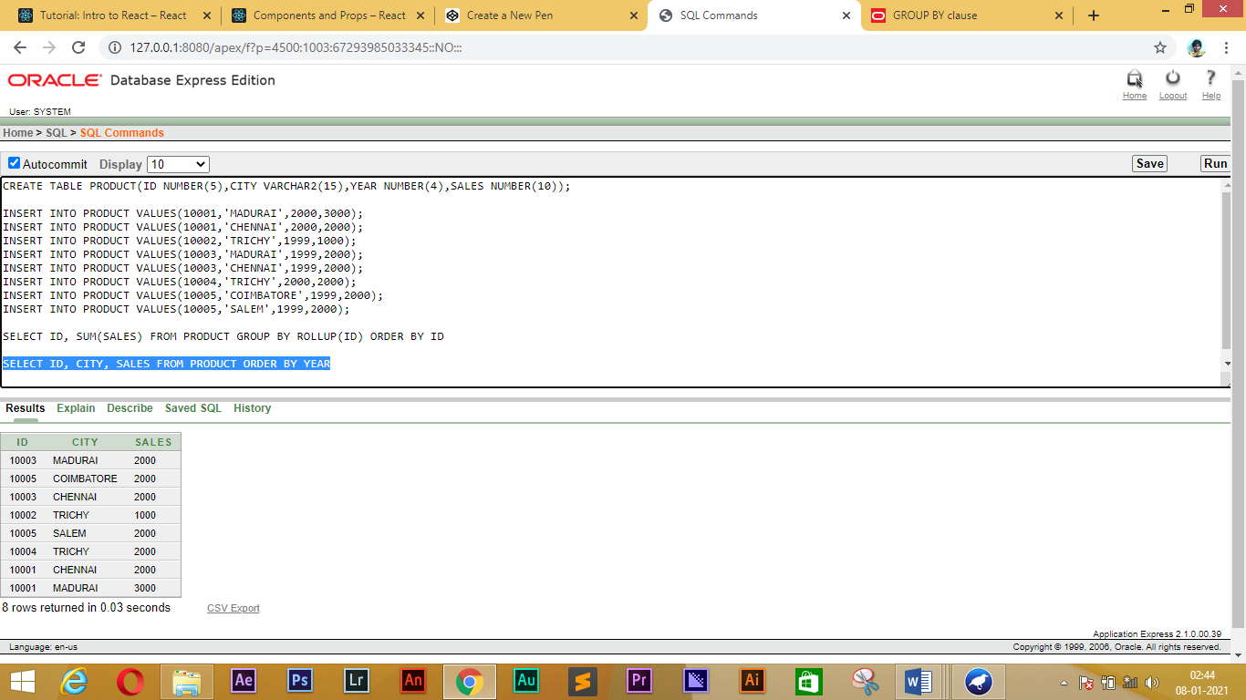

**SLICE:**

**SQL>** **SELECT * FROM PRODUCT WHERE ID=10001**

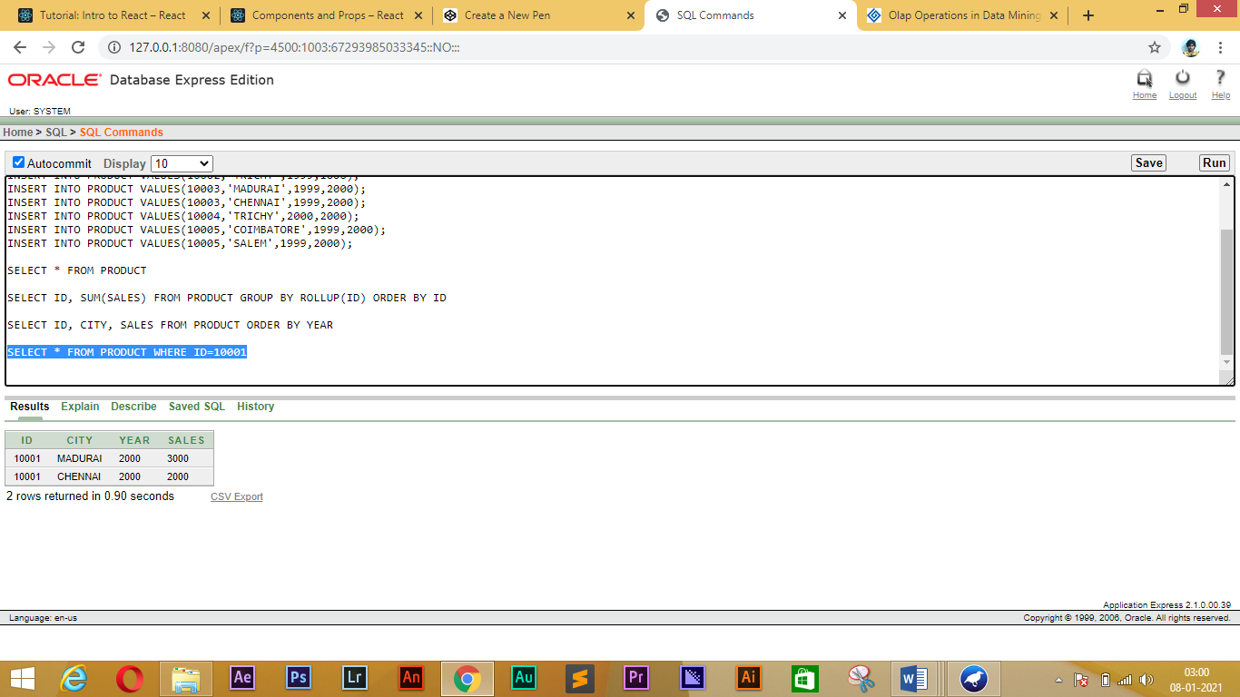

**DICE:**

**SQL>** **SELECT * FROM PRODUCT WHERE ID=10005 AND YEAR=1999**

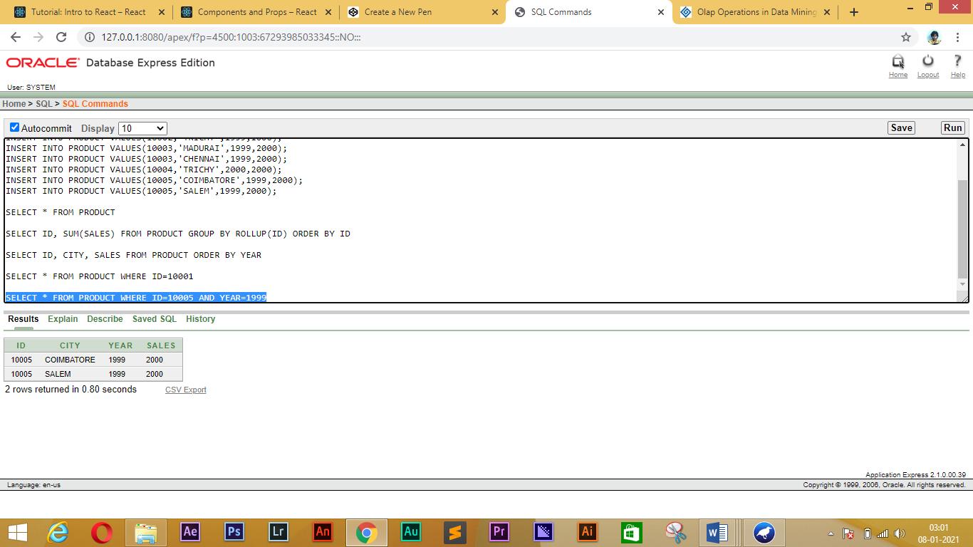

**PIVOT:**

**SQL>select ID,**

**sum(case when CITY ='MADURAI' then SALES else 0 end) MDU,**

**sum(case when CITY='CHENNAI' then SALES else 0 end) CHE,**

**sum(case when CITY='COIMBATORE' then SALES else 0 end) CBE,**

**sum(case when CITY='TRICHY' then SALES else 0 end) TRI,**

**sum(case when CITY='SALEM' then SALES else 0 end) SAL**

**from PRODUCT**

**group by ID;**

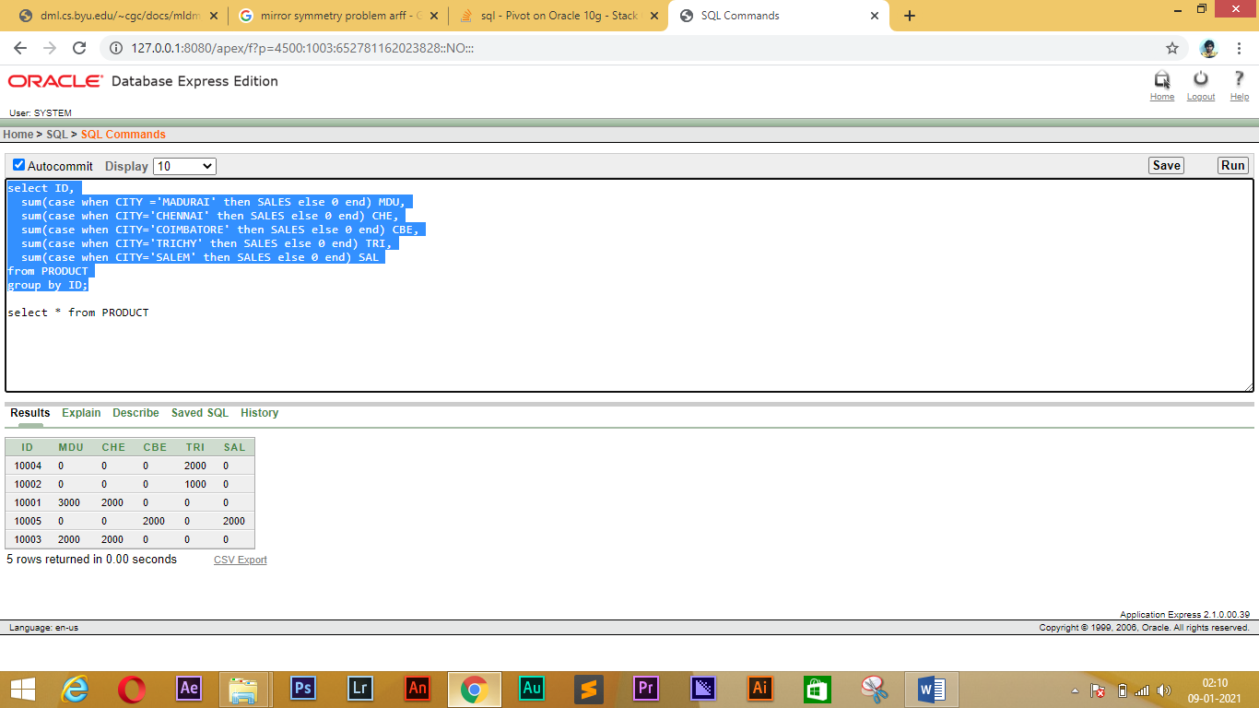

**RESULT:**

Various OLAP operations such slice, dice, roll up, drill up, pivot etc. are performed.

**EXPERIMENT-4**

**AIM**:

To perform the Data Processing for data mining using WEKA Tool

**Procedure:**

Introduce the datasets sick, vote, mushroom and letter.

**Apply discretization:**

• load the sick dataset and look at the attributes

• classify using NB, evaluating with cross-validation

• apply the supervised discretization filter and look at the effect (in the Preprocess panel)

• apply unsupervised discretization with different numbers of bins and look at the effect

• use the FilteredClassifier with NB and supervised discretization, evaluating with cross-validation

• repeat using unsupervised discretization with different numbers of bins

• compare and interpret the results.

**Apply feature selection using CfsSubsetEval**

• load the mushroom dataset and apply J48, IBk and NB, evaluating with crossvalidation

• select attributes using CfsSubsetEval and GreedyStepwise search

• interpret the results

• use AttributeSelectedClassifier (with CfsSubsetEval and GreedyStepwise

• search) for classifiers J48, IBk and NB, evaluating with cross-validation

• interpret the results.

**Apply feature selection using WrapperSubsetEval:**

• load the vote dataset and apply J48, IBk and NB, evaluating with crossvalidation

• select attributes using WrapperSubsetEval with InfoGainAttributeEval and RankSearch, with the J48 classifier

• interpret the results

• use AttributeSelectedClassifier (with WrapperSubsetEval, InfoGainAttributeEval and RankSearch) with classifiers J48, IBk and NB, evaluating with cross-validation

• interpret the results.

**Sampling a dataset:**

• load the letter dataset and examine a particular (numeric) attribute

• apply the Resample filter to select half the dataset

• examine the same attribute and comment on the results.

**APPLY DISCRETIZATION:**

**1) Loading ‘Sick’ dataset:**

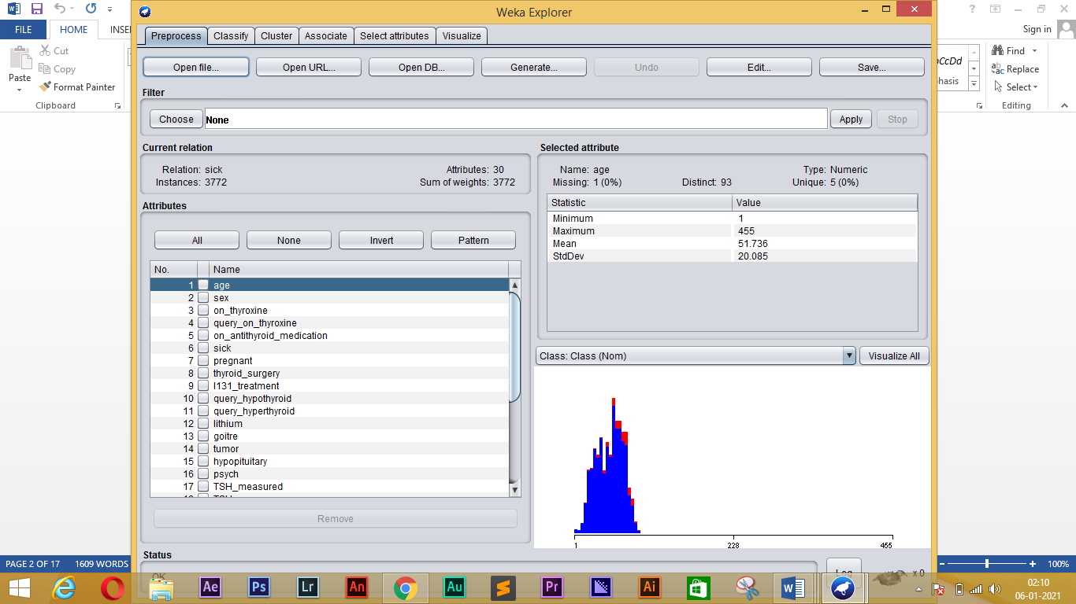

**2) WITHOUT PREPROCESSING:**

Time taken to build model: 0.11 seconds

=== Stratified cross-validation ===

=== Summary ===

Correctly Classified Instances 3493 92.6034 %

Incorrectly Classified Instances 279 7.3966 %

Kappa statistic 0.5249

Mean absolute error 0.0888

Root mean squared error 0.2294

Relative absolute error 77.0863 %

Root relative squared error 95.6866 %

Total Number of Instances 3772

=== Detailed Accuracy By Class ===

TP Rate FP Rate Precision Recall F-Measure MCC ROC Area PRC Area Class

0.936 0.225 0.985 0.936 0.960 0.550 0.925 0.991 negative

0.775 0.064 0.441 0.775 0.562 0.550 0.925 0.660 sick

Weighted Avg. 0.926 0.215 0.951 0.926 0.935 0.550 0.925 0.971

=== Confusion Matrix ===

a b <-- classified as

3314 227 | a = negative

52 179 | b = sick

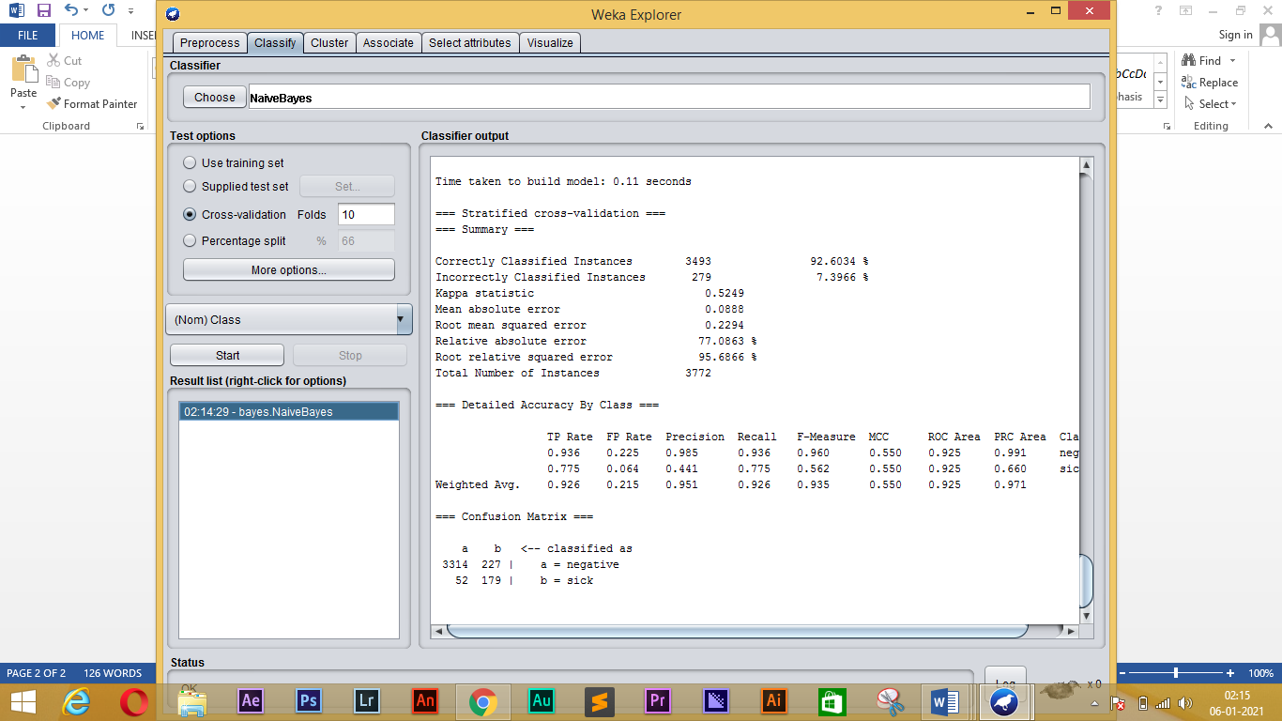

**3) SUPERVISED DISCRETIZATION:**

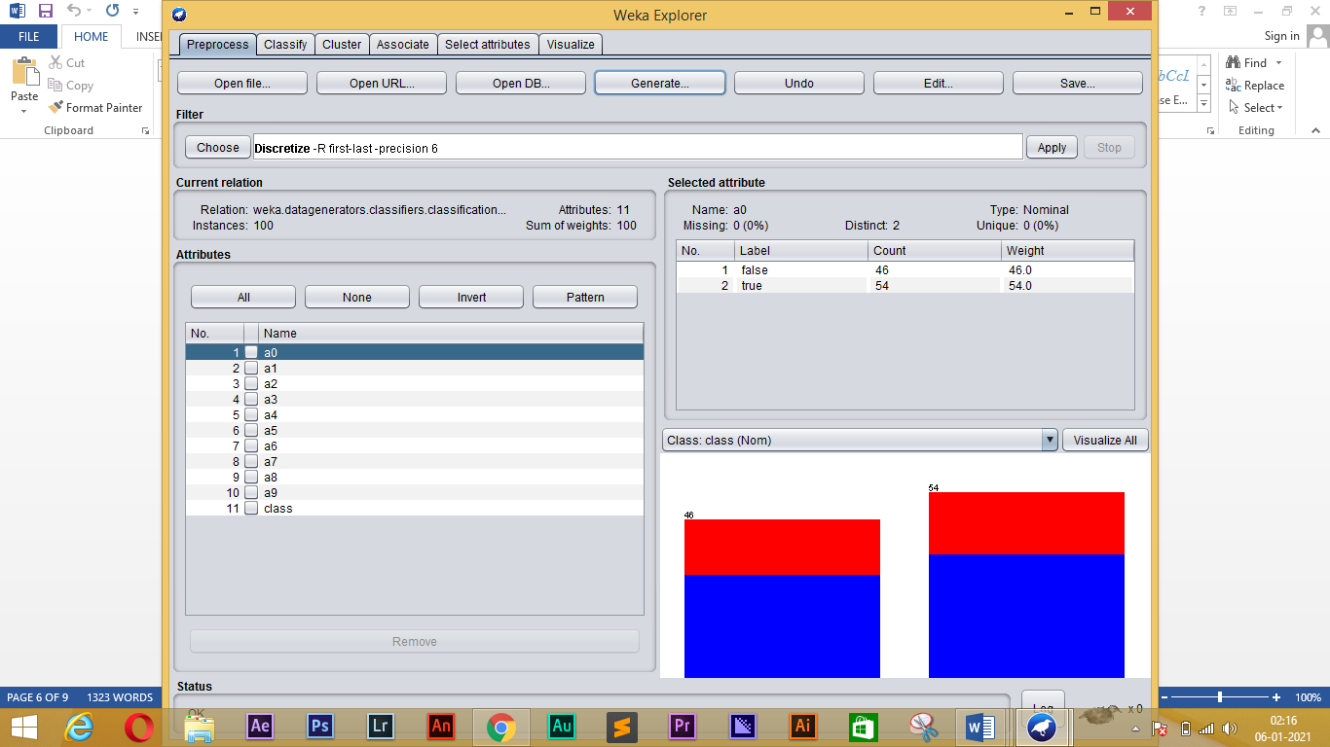

Time taken to build model: 0 seconds

=== Stratified cross-validation ===

=== Summary ===

Correctly Classified Instances 77 77 %

Incorrectly Classified Instances 23 23 %

Kappa statistic 0.4838

Mean absolute error 0.3108

Root mean squared error 0.3921

Relative absolute error 68.9937 %

Root relative squared error 82.6609 %

Total Number of Instances 100

=== Detailed Accuracy By Class ===

TP Rate FP Rate Precision Recall F-Measure MCC ROC Area PRC Area Class

0.833 0.353 0.821 0.833 0.827 0.484 0.820 0.870 c0

0.647 0.167 0.667 0.647 0.657 0.484 0.820 0.660 c1

Weighted Avg. 0.770 0.290 0.768 0.770 0.769 0.484 0.820 0.799

=== Confusion Matrix ===

a b <-- classified as

55 11 | a = c0

12 22 | b = c1

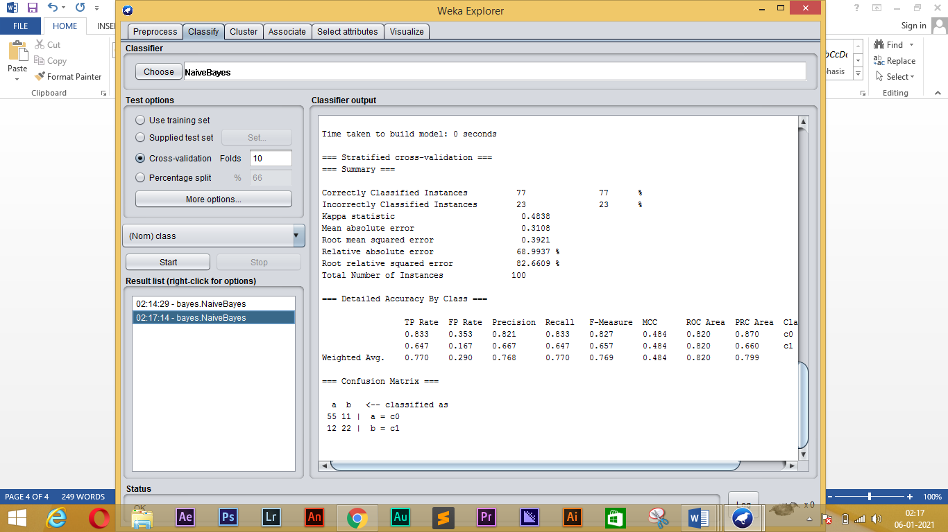

**4) UNSUPERVISED DISCRETIZATION:**

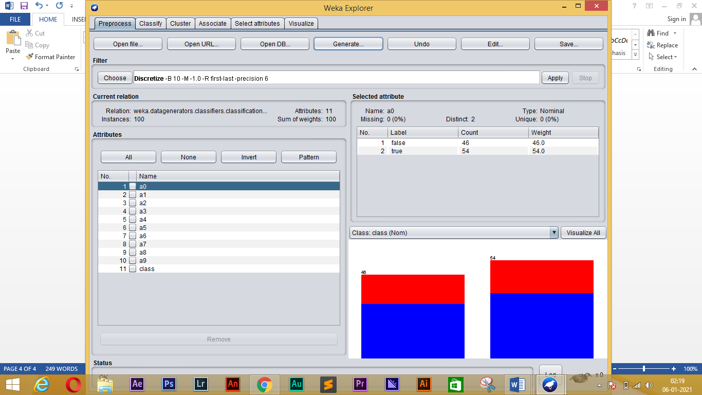

Time taken to build model: 0 seconds

=== Stratified cross-validation ===

=== Summary ===

Correctly Classified Instances 77 77 %

Incorrectly Classified Instances 23 23 %

Kappa statistic 0.4838

Mean absolute error 0.3108

Root mean squared error 0.3921

Relative absolute error 68.9937 %

Root relative squared error 82.6609 %

Total Number of Instances 100

=== Detailed Accuracy By Class ===

TP Rate FP Rate Precision Recall F-Measure MCC ROC Area PRC Area Class

0.833 0.353 0.821 0.833 0.827 0.484 0.820 0.870 c0

0.647 0.167 0.667 0.647 0.657 0.484 0.820 0.660 c1

Weighted Avg. 0.770 0.290 0.768 0.770 0.769 0.484 0.820 0.799

=== Confusion Matrix ===

a b <-- classified as

55 11 | a = c0

12 22 | b = c1

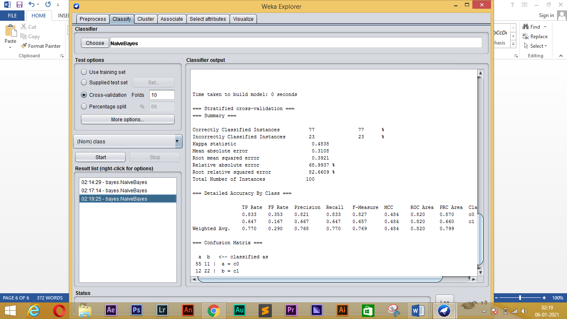

**APPLY FEATURE SELECTION USING ‘CfsSubsetEval’:**

**1) LOAD THE ‘MUSHROOM’ DATASET:**

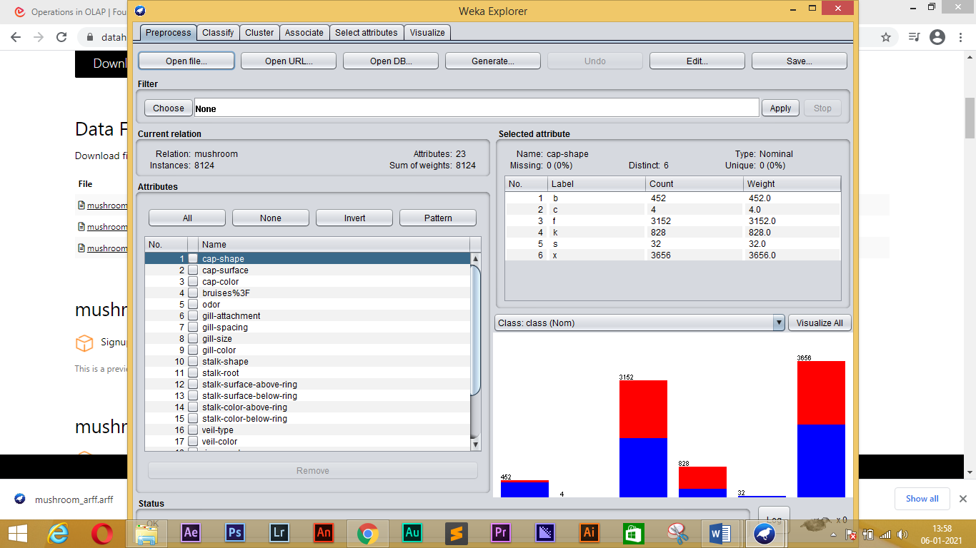

**2)** **select attributes using CfsSubsetEval and GreedyStepwise search:**

=== Run information ===

Evaluator: weka.attributeSelection.CfsSubsetEval -P 1 -E 1

Search: weka.attributeSelection.GreedyStepwise -T -1.7976931348623157E308 -N -1 -num-slots 1

Relation: mushroom

Instances: 8124

Attributes: 23

cap-shape

cap-surface

cap-color

bruises%3F

odor

gill-attachment

gill-spacing

gill-size

gill-color

stalk-shape

stalk-root

stalk-surface-above-ring

stalk-surface-below-ring

stalk-color-above-ring

stalk-color-below-ring

veil-type

veil-color

ring-number

ring-type

spore-print-color

population

habitat

class

Evaluation mode: 10-fold cross-validation

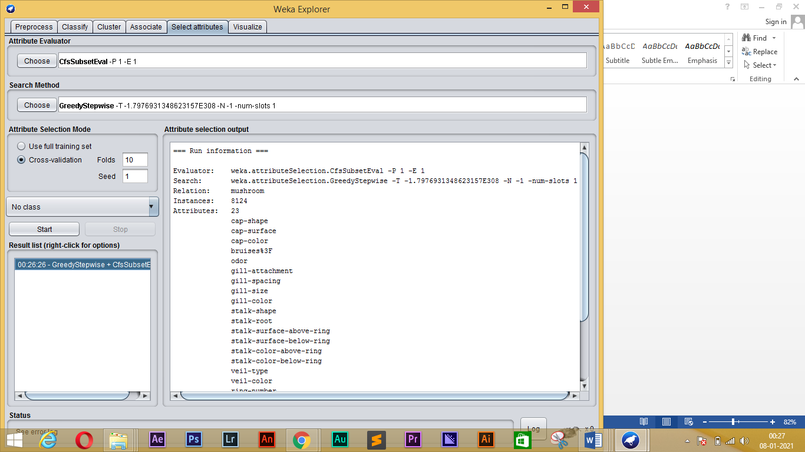

**3)** **Apply J48, IBk and NB, evaluating with crossvalidation:**

**NaiveBayes:**

=== Run information ===

Scheme: weka.classifiers.bayes.NaiveBayes

Relation: mushroom

Instances: 8124

Attributes: 23

cap-shape

cap-surface

cap-color

bruises%3F

odor

gill-attachment

gill-spacing

gill-size

gill-color

stalk-shape

stalk-root

stalk-surface-above-ring

stalk-surface-below-ring

stalk-color-above-ring

stalk-color-below-ring

veil-type

veil-color

ring-number

ring-type

spore-print-color

population

habitat

class

Test mode: 10-fold cross-validation

=== Classifier model (full training set) ===

Naive Bayes Classifier

Class

Attribute e p

(0.52) (0.48)

=========================================

cap-shape

b 405.0 49.0

c 1.0 5.0

f 1597.0 1557.0

k 229.0 601.0

s 33.0 1.0

x 1949.0 1709.0

[total] 4214.0 3922.0

cap-surface

f 1561.0 761.0

g 1.0 5.0

s 1145.0 1413.0

y 1505.0 1741.0

[total] 4212.0 3920.0

cap-color

b 49.0 121.0

c 33.0 13.0

e 625.0 877.0

g 1033.0 809.0

n 1265.0 1021.0

p 57.0 89.0

r 17.0 1.0

u 17.0 1.0

w 721.0 321.0

y 401.0 673.0

[total] 4218.0 3926.0

bruises%3F

f 1457.0 3293.0

t 2753.0 625.0

[total] 4210.0 3918.0

odor

a 401.0 1.0

c 1.0 193.0

f 1.0 2161.0

l 401.0 1.0

m 1.0 37.0

n 3409.0 121.0

p 1.0 257.0

s 1.0 577.0

y 1.0 577.0

[total] 4217.0 3925.0

gill-attachment

a 193.0 19.0

d 1.0 1.0

f 4017.0 3899.0

n 1.0 1.0

[total] 4212.0 3920.0

gill-spacing

c 3009.0 3805.0

d 1.0 1.0

w 1201.0 113.0

[total] 4211.0 3919.0

gill-size

b 3921.0 1693.0

n 289.0 2225.0

[total] 4210.0 3918.0

gill-color

b 1.0 1729.0

e 97.0 1.0

g 249.0 505.0

h 205.0 529.0

k 345.0 65.0

n 937.0 113.0

o 65.0 1.0

p 853.0 641.0

r 1.0 25.0

u 445.0 49.0

w 957.0 247.0

y 65.0 23.0

[total] 4220.0 3928.0

stalk-shape

e 1617.0 1901.0

t 2593.0 2017.0

[total] 4210.0 3918.0

stalk-root

b 1921.0 1857.0

c 513.0 45.0

e 865.0 257.0

r 193.0 1.0

u 1.0 1.0

z 1.0 1.0

[total] 3494.0 2162.0

stalk-surface-above-ring

f 409.0 145.0

k 145.0 2229.0

s 3641.0 1537.0

y 17.0 9.0

[total] 4212.0 3920.0

stalk-surface-below-ring

f 457.0 145.0

k 145.0 2161.0

s 3401.0 1537.0

y 209.0 77.0

[total] 4212.0 3920.0

stalk-color-above-ring

b 1.0 433.0

c 1.0 37.0

e 97.0 1.0

g 577.0 1.0

n 17.0 433.0

o 193.0 1.0

p 577.0 1297.0

w 2753.0 1713.0

y 1.0 9.0

[total] 4217.0 3925.0

stalk-color-below-ring

b 1.0 433.0

c 1.0 37.0

e 97.0 1.0

g 577.0 1.0

n 65.0 449.0

o 193.0 1.0

p 577.0 1297.0

w 2705.0 1681.0

y 1.0 25.0

[total] 4217.0 3925.0

veil-type

p 4209.0 3917.0

u 1.0 1.0

[total] 4210.0 3918.0

veil-color

n 97.0 1.0

o 97.0 1.0

w 4017.0 3909.0

y 1.0 9.0

[total] 4212.0 3920.0

ring-number

n 1.0 37.0

o 3681.0 3809.0

t 529.0 73.0

[total] 4211.0 3919.0

ring-type

c 1.0 1.0

e 1009.0 1769.0

f 49.0 1.0

l 1.0 1297.0

n 1.0 37.0

p 3153.0 817.0

s 1.0 1.0

z 1.0 1.0

[total] 4216.0 3924.0

spore-print-color

b 49.0 1.0

h 49.0 1585.0

k 1649.0 225.0

n 1745.0 225.0

o 49.0 1.0

r 1.0 73.0

u 49.0 1.0

w 577.0 1813.0

y 49.0 1.0

[total] 4217.0 3925.0

population

a 385.0 1.0

c 289.0 53.0

n 401.0 1.0

s 881.0 369.0

v 1193.0 2849.0

y 1065.0 649.0

[total] 4214.0 3922.0

habitat

d 1881.0 1269.0

g 1409.0 741.0

l 241.0 593.0

m 257.0 37.0

p 137.0 1009.0

u 97.0 273.0

w 193.0 1.0

[total] 4215.0 3923.0

Time taken to build model: 0.08 seconds

=== Stratified cross-validation ===

=== Summary ===

Correctly Classified Instances 7785 95.8272 %

Incorrectly Classified Instances 339 4.1728 %

Kappa statistic 0.9162

Mean absolute error 0.0419

Root mean squared error 0.1757

Relative absolute error 8.397 %

Root relative squared error 35.1617 %

Total Number of Instances 8124

=== Detailed Accuracy By Class ===

TP Rate FP Rate Precision Recall F-Measure MCC ROC Area PRC Area Class

0.992 0.078 0.932 0.992 0.961 0.918 0.998 0.998 e

0.922 0.008 0.991 0.922 0.955 0.918 0.998 0.998 p

Weighted Avg. 0.958 0.044 0.960 0.958 0.958 0.918 0.998 0.998

=== Confusion Matrix ===

a b <-- classified as

4176 32 | a = e

307 3609 | b = p

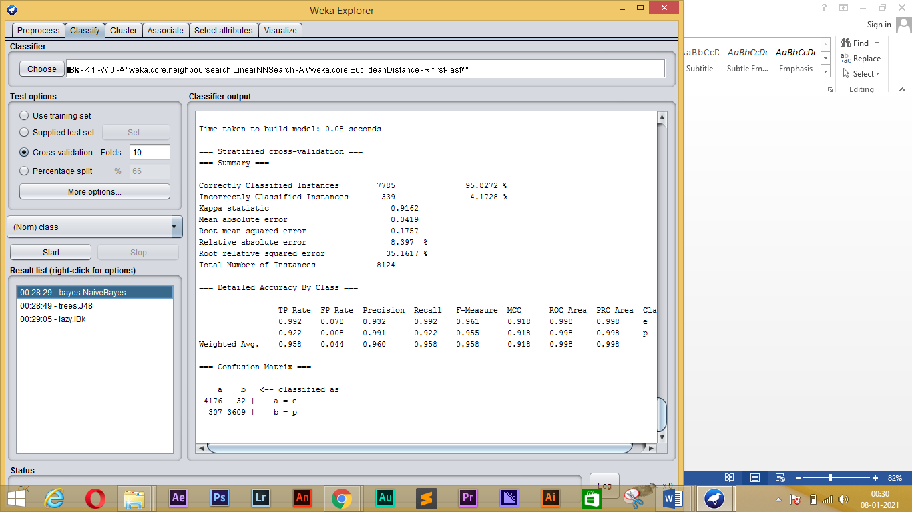

**IBk:**

=== Run information ===

Scheme: weka.classifiers.lazy.IBk -K 1 -W 0 -A "weka.core.neighboursearch.LinearNNSearch -A \"weka.core.EuclideanDistance -R first-last\""

Relation: mushroom

Instances: 8124

Attributes: 23

cap-shape

cap-surface

cap-color

bruises%3F

odor

gill-attachment

gill-spacing

gill-size

gill-color

stalk-shape

stalk-root

stalk-surface-above-ring

stalk-surface-below-ring

stalk-color-above-ring

stalk-color-below-ring

veil-type

veil-color

ring-number

ring-type

spore-print-color

population

habitat

class

Test mode: 10-fold cross-validation

=== Classifier model (full training set) ===

IB1 instance-based classifier

using 1 nearest neighbour(s) for classification

Time taken to build model: 0.04 seconds

=== Stratified cross-validation ===

=== Summary ===

Correctly Classified Instances 8124 100 %

Incorrectly Classified Instances 0 0 %

Kappa statistic 1

Mean absolute error 0

Root mean squared error 0

Relative absolute error 0.0029 %

Root relative squared error 0.003 %

Total Number of Instances 8124

=== Detailed Accuracy By Class ===

TP Rate FP Rate Precision Recall F-Measure MCC ROC Area PRC Area Class

1.000 0.000 1.000 1.000 1.000 1.000 1.000 1.000 e

1.000 0.000 1.000 1.000 1.000 1.000 1.000 1.000 p

Weighted Avg. 1.000 0.000 1.000 1.000 1.000 1.000 1.000 1.000

=== Confusion Matrix ===

a b <-- classified as

4208 0 | a = e

0 3916 | b = p

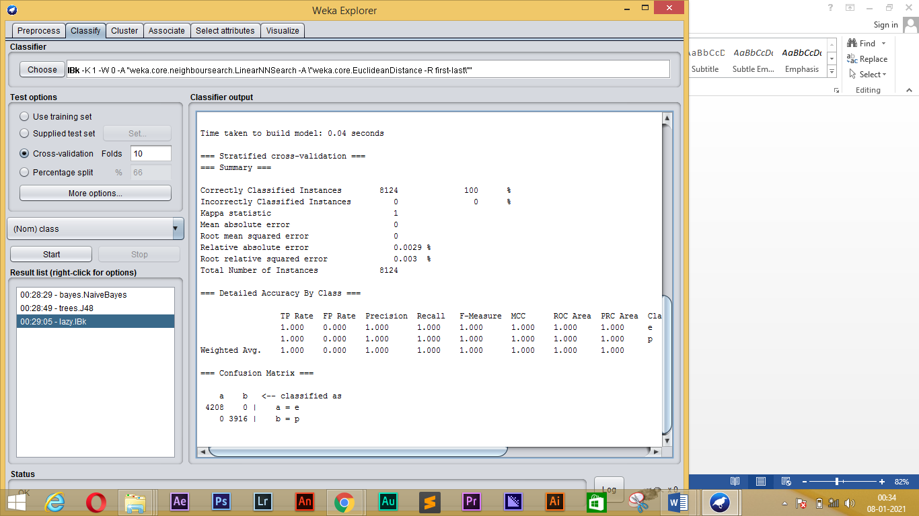

**J48:**

=== Run information ===

Scheme: weka.classifiers.trees.J48 -C 0.25 -M 2

Relation: mushroom

Instances: 8124

Attributes: 23

cap-shape

cap-surface

cap-color

bruises%3F

odor

gill-attachment

gill-spacing

gill-size

gill-color

stalk-shape

stalk-root

stalk-surface-above-ring

stalk-surface-below-ring

stalk-color-above-ring

stalk-color-below-ring

veil-type

veil-color

ring-number

ring-type

spore-print-color

population

habitat

class

Test mode: 10-fold cross-validation

=== Classifier model (full training set) ===

J48 pruned tree

------------------

odor = a: e (400.0)

odor = c: p (192.0)

odor = f: p (2160.0)

odor = l: e (400.0)

odor = m: p (36.0)

odor = n

| spore-print-color = b: e (48.0)

| spore-print-color = h: e (48.0)

| spore-print-color = k: e (1296.0)

| spore-print-color = n: e (1344.0)

| spore-print-color = o: e (48.0)

| spore-print-color = r: p (72.0)

| spore-print-color = u: e (0.0)

| spore-print-color = w

| | gill-size = b: e (528.0)

| | gill-size = n

| | | gill-spacing = c: p (32.0)

| | | gill-spacing = d: e (0.0)

| | | gill-spacing = w

| | | | population = a: e (0.0)

| | | | population = c: p (16.0)

| | | | population = n: e (0.0)

| | | | population = s: e (0.0)

| | | | population = v: e (48.0)

| | | | population = y: e (0.0)

| spore-print-color = y: e (48.0)

odor = p: p (256.0)

odor = s: p (576.0)

odor = y: p (576.0)

Number of Leaves : 25

Size of the tree : 30

Time taken to build model: 0.2 seconds

=== Stratified cross-validation ===

=== Summary ===

Correctly Classified Instances 8124 100 %

Incorrectly Classified Instances 0 0 %

Kappa statistic 1

Mean absolute error 0

Root mean squared error 0

Relative absolute error 0 %

Root relative squared error 0 %

Total Number of Instances 8124

=== Detailed Accuracy By Class ===

TP Rate FP Rate Precision Recall F-Measure MCC ROC Area PRC Area Class

1.000 0.000 1.000 1.000 1.000 1.000 1.000 1.000 e

1.000 0.000 1.000 1.000 1.000 1.000 1.000 1.000 p

Weighted Avg. 1.000 0.000 1.000 1.000 1.000 1.000 1.000 1.000

=== Confusion Matrix ===

a b <-- classified as

4208 0 | a = e

0 3916 | b = p

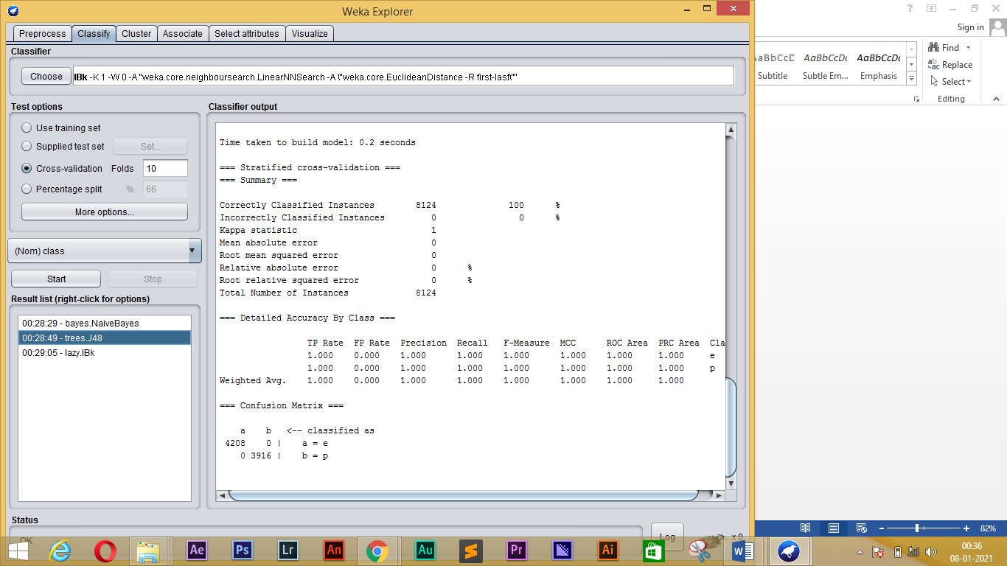

**4) Use AttributeSelectedClassifier (with CfsSubsetEval and GreedyStepwise):**

**For NB:**

=== Run information ===

Scheme: weka.classifiers.meta.AttributeSelectedClassifier -E "weka.attributeSelection.CfsSubsetEval -P 1 -E 1" -S "weka.attributeSelection.BestFirst -D 1 -N 5" -W weka.classifiers.bayes.NaiveBayes

Relation: mushroom

Instances: 8124

Attributes: 23

cap-shape

cap-surface

cap-color

bruises%3F

odor

gill-attachment

gill-spacing

gill-size

gill-color

stalk-shape

stalk-root

stalk-surface-above-ring

stalk-surface-below-ring

stalk-color-above-ring

stalk-color-below-ring

veil-type

veil-color

ring-number

ring-type

spore-print-color

population

habitat

class

Test mode: 10-fold cross-validation

=== Classifier model (full training set) ===

AttributeSelectedClassifier:

=== Attribute Selection on all input data ===

Search Method:

Best first.

Start set: no attributes

Search direction: forward

Stale search after 5 node expansions

Total number of subsets evaluated: 118

Merit of best subset found: 0.546

Attribute Subset Evaluator (supervised, Class (nominal): 23 class):

CFS Subset Evaluator

Including locally predictive attributes

Selected attributes: 5,7,12,17 : 4

odor

gill-spacing

stalk-surface-above-ring

veil-color

Header of reduced data:

@relation 'mushroom-weka.filters.unsupervised.attribute.Remove-V-R5,7,12,17,23'

@attribute odor {a,c,f,l,m,n,p,s,y}

@attribute gill-spacing {c,d,w}

@attribute stalk-surface-above-ring {f,k,s,y}

@attribute veil-color {n,o,w,y}

@attribute class {e,p}

@data

Classifier Model

Naive Bayes Classifier

Class

Attribute e p

(0.52) (0.48)

=========================================

odor

a 401.0 1.0

c 1.0 193.0

f 1.0 2161.0

l 401.0 1.0

m 1.0 37.0

n 3409.0 121.0

p 1.0 257.0

s 1.0 577.0

y 1.0 577.0

[total] 4217.0 3925.0

gill-spacing

c 3009.0 3805.0

d 1.0 1.0

w 1201.0 113.0

[total] 4211.0 3919.0

stalk-surface-above-ring

f 409.0 145.0

k 145.0 2229.0

s 3641.0 1537.0

y 17.0 9.0

[total] 4212.0 3920.0

veil-color

n 97.0 1.0

o 97.0 1.0

w 4017.0 3909.0

y 1.0 9.0

[total] 4212.0 3920.0

Time taken to build model: 0.32 seconds

=== Stratified cross-validation ===

=== Summary ===

Correctly Classified Instances 8004 98.5229 %

Incorrectly Classified Instances 120 1.4771 %

Kappa statistic 0.9704

Mean absolute error 0.0219

Root mean squared error 0.1092

Relative absolute error 4.3851 %

Root relative squared error 21.8623 %

Total Number of Instances 8124

=== Detailed Accuracy By Class ===

TP Rate FP Rate Precision Recall F-Measure MCC ROC Area PRC Area Class

1.000 0.031 0.972 1.000 0.986 0.971 0.991 0.989 e

0.969 0.000 1.000 0.969 0.984 0.971 0.991 0.993 p

Weighted Avg. 0.985 0.016 0.986 0.985 0.985 0.971 0.991 0.991

=== Confusion Matrix ===

a b <-- classified as

4208 0 | a = e

120 3796 | b = p

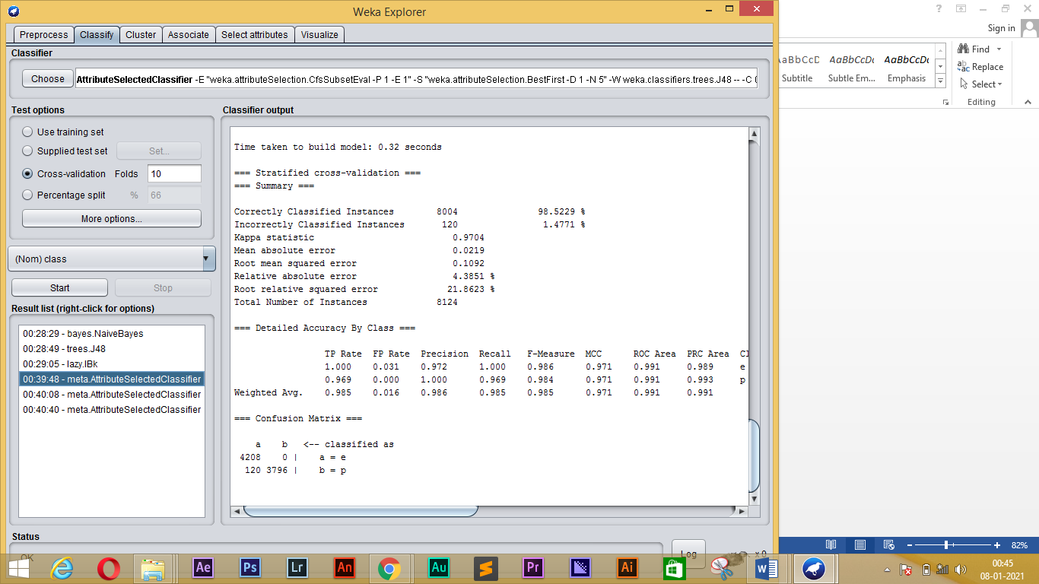

**FOR J48:**

=== Run information ===

Scheme: weka.classifiers.meta.AttributeSelectedClassifier -E "weka.attributeSelection.CfsSubsetEval -P 1 -E 1" -S "weka.attributeSelection.BestFirst -D 1 -N 5" -W weka.classifiers.trees.J48 -- -C 0.25 -M 2

Relation: mushroom

Instances: 8124

Attributes: 23

cap-shape

cap-surface

cap-color

bruises%3F

odor

gill-attachment

gill-spacing

gill-size

gill-color

stalk-shape

stalk-root

stalk-surface-above-ring

stalk-surface-below-ring

stalk-color-above-ring

stalk-color-below-ring

veil-type

veil-color

ring-number

ring-type

spore-print-color

population

habitat

class

Test mode: 10-fold cross-validation

=== Classifier model (full training set) ===

AttributeSelectedClassifier:

=== Attribute Selection on all input data ===

Search Method:

Best first.

Start set: no attributes

Search direction: forward

Stale search after 5 node expansions

Total number of subsets evaluated: 118

Merit of best subset found: 0.546

Attribute Subset Evaluator (supervised, Class (nominal): 23 class):

CFS Subset Evaluator

Including locally predictive attributes

Selected attributes: 5,7,12,17 : 4

odor

gill-spacing

stalk-surface-above-ring

veil-color

Header of reduced data:

@relation 'mushroom-weka.filters.unsupervised.attribute.Remove-V-R5,7,12,17,23'

@attribute odor {a,c,f,l,m,n,p,s,y}

@attribute gill-spacing {c,d,w}

@attribute stalk-surface-above-ring {f,k,s,y}

@attribute veil-color {n,o,w,y}

@attribute class {e,p}

@data

Classifier Model

J48 pruned tree

------------------

odor = a: e (400.0)

odor = c: p (192.0)

odor = f: p (2160.0)

odor = l: e (400.0)

odor = m: p (36.0)

odor = n

| veil-color = n: e (96.0)

| veil-color = o: e (96.0)

| veil-color = w

| | stalk-surface-above-ring = f: e (408.0)

| | stalk-surface-above-ring = k

| | | gill-spacing = c: p (32.0)

| | | gill-spacing = d: e (0.0)

| | | gill-spacing = w: e (144.0)

| | stalk-surface-above-ring = s: e (2728.0/80.0)

| | stalk-surface-above-ring = y: e (16.0)

| veil-color = y: p (8.0)

odor = p: p (256.0)

odor = s: p (576.0)

odor = y: p (576.0)

Number of Leaves : 17

Size of the tree : 21

Time taken to build model: 0.14 seconds

=== Stratified cross-validation ===

=== Summary ===

Correctly Classified Instances 8044 99.0153 %

Incorrectly Classified Instances 80 0.9847 %

Kappa statistic 0.9803

Mean absolute error 0.0191

Root mean squared error 0.0978

Relative absolute error 3.825 %

Root relative squared error 19.5792 %

Total Number of Instances 8124

=== Detailed Accuracy By Class ===

TP Rate FP Rate Precision Recall F-Measure MCC ROC Area PRC Area Class

1.000 0.020 0.981 1.000 0.991 0.980 0.992 0.990 e

0.980 0.000 1.000 0.980 0.990 0.980 0.992 0.994 p

Weighted Avg. 0.990 0.011 0.990 0.990 0.990 0.980 0.992 0.992

=== Confusion Matrix ===

a b <-- classified as

4208 0 | a = e

80 3836 | b = p

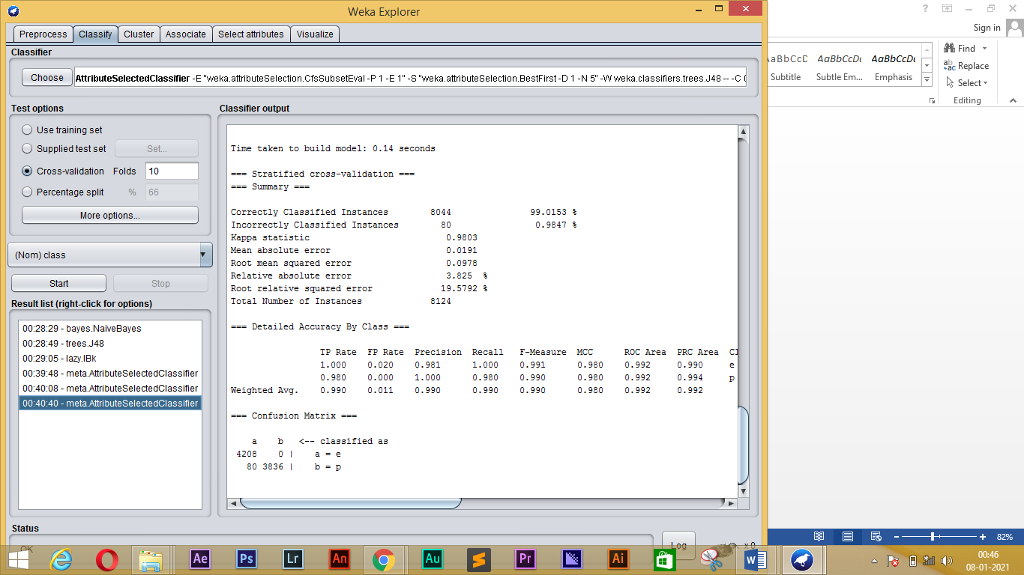

**For IBk:**

=== Run information ===

Scheme: weka.classifiers.meta.AttributeSelectedClassifier -E "weka.attributeSelection.CfsSubsetEval -P 1 -E 1" -S "weka.attributeSelection.BestFirst -D 1 -N 5" -W weka.classifiers.lazy.IBk -- -K 1 -W 0 -A "weka.core.neighboursearch.LinearNNSearch -A \"weka.core.EuclideanDistance -R first-last\""

Relation: mushroom

Instances: 8124

Attributes: 23

cap-shape

cap-surface

cap-color

bruises%3F

odor

gill-attachment

gill-spacing

gill-size

gill-color

stalk-shape

stalk-root

stalk-surface-above-ring

stalk-surface-below-ring

stalk-color-above-ring

stalk-color-below-ring

veil-type

veil-color

ring-number

ring-type

spore-print-color

population

habitat

class

Test mode: 10-fold cross-validation

=== Classifier model (full training set) ===

AttributeSelectedClassifier:

=== Attribute Selection on all input data ===

Search Method:

Best first.

Start set: no attributes

Search direction: forward

Stale search after 5 node expansions

Total number of subsets evaluated: 118

Merit of best subset found: 0.546

Attribute Subset Evaluator (supervised, Class (nominal): 23 class):

CFS Subset Evaluator

Including locally predictive attributes

Selected attributes: 5,7,12,17 : 4

odor

gill-spacing

stalk-surface-above-ring

veil-color

Header of reduced data:

@relation 'mushroom-weka.filters.unsupervised.attribute.Remove-V-R5,7,12,17,23'

@attribute odor {a,c,f,l,m,n,p,s,y}

@attribute gill-spacing {c,d,w}

@attribute stalk-surface-above-ring {f,k,s,y}

@attribute veil-color {n,o,w,y}

@attribute class {e,p}

@data

Classifier Model

IB1 instance-based classifier

using 1 nearest neighbour(s) for classification

Time taken to build model: 0.11 seconds

=== Stratified cross-validation ===

=== Summary ===

Correctly Classified Instances 8044 99.0153 %

Incorrectly Classified Instances 80 0.9847 %

Kappa statistic 0.9803

Mean absolute error 0.0191

Root mean squared error 0.0977

Relative absolute error 3.8219 %

Root relative squared error 19.5564 %

Total Number of Instances 8124

=== Detailed Accuracy By Class ===

TP Rate FP Rate Precision Recall F-Measure MCC ROC Area PRC Area Class

1.000 0.020 0.981 1.000 0.991 0.980 0.993 0.992 e

0.980 0.000 1.000 0.980 0.990 0.980 0.993 0.995 p

Weighted Avg. 0.990 0.011 0.990 0.990 0.990 0.980 0.993 0.993

=== Confusion Matrix ===

a b <-- classified as

4208 0 | a = e

80 3836 | b = p

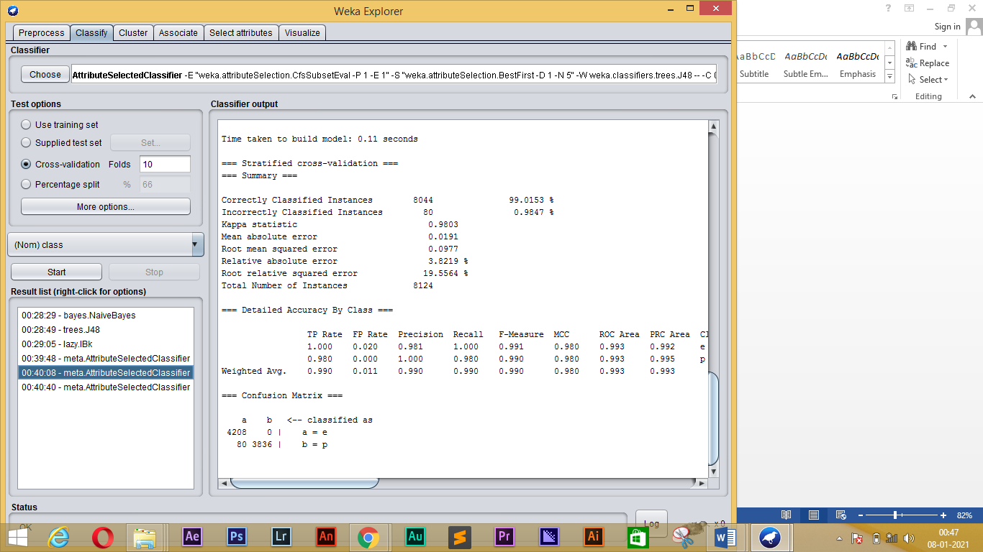

**Apply feature selection using WrapperSubsetEval:**

**1) Load the vote dataset:**

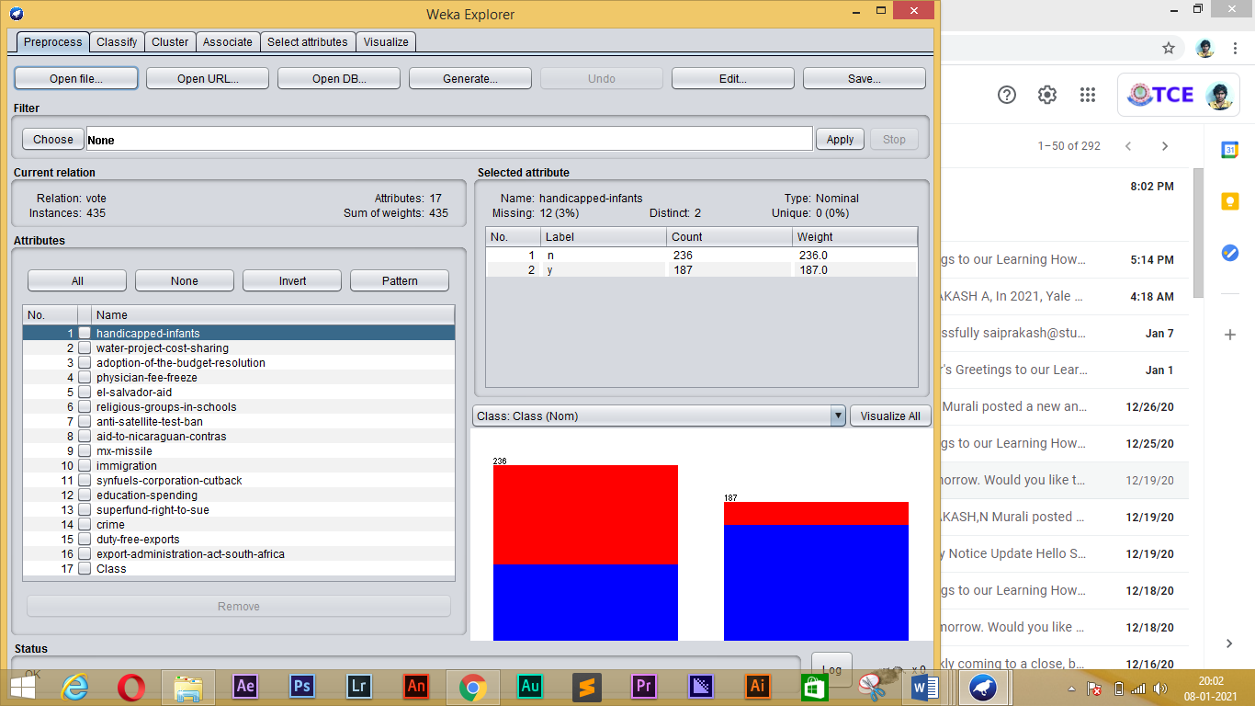

**2, select attributes using WrapperSubsetEval with the J48 classifier:**

=== Run information ===

Evaluator: weka.attributeSelection.WrapperSubsetEval -B weka.classifiers.trees.J48 -F 5 -T 0.01 -R 1 -E DEFAULT -- -C 0.25 -M 2

Search: weka.attributeSelection.GreedyStepwise -T -1.7976931348623157E308 -N -1 -num-slots 1

Relation: vote

Instances: 435

Attributes: 17

handicapped-infants

water-project-cost-sharing

adoption-of-the-budget-resolution

physician-fee-freeze

el-salvador-aid

religious-groups-in-schools

anti-satellite-test-ban

aid-to-nicaraguan-contras

mx-missile

immigration

synfuels-corporation-cutback

education-spending

superfund-right-to-sue

crime

duty-free-exports

export-administration-act-south-africa

Class

Evaluation mode: 10-fold cross-validation

**WITH J48:**

=== Run information ===

Scheme: weka.classifiers.trees.J48 -C 0.25 -M 2

Relation: vote

Instances: 435

Attributes: 17

handicapped-infants

water-project-cost-sharing

adoption-of-the-budget-resolution

physician-fee-freeze

el-salvador-aid

religious-groups-in-schools

anti-satellite-test-ban

aid-to-nicaraguan-contras

mx-missile

immigration

synfuels-corporation-cutback

education-spending

superfund-right-to-sue

crime

duty-free-exports

export-administration-act-south-africa

Class

Test mode: 10-fold cross-validation

=== Classifier model (full training set) ===

J48 pruned tree

------------------

physician-fee-freeze = n: democrat (253.41/3.75)

physician-fee-freeze = y

| synfuels-corporation-cutback = n: republican (145.71/4.0)

| synfuels-corporation-cutback = y

| | mx-missile = n

| | | adoption-of-the-budget-resolution = n: republican (22.61/3.32)

| | | adoption-of-the-budget-resolution = y

| | | | anti-satellite-test-ban = n: democrat (5.04/0.02)

| | | | anti-satellite-test-ban = y: republican (2.21)

| | mx-missile = y: democrat (6.03/1.03)

Number of Leaves : 6

Size of the tree : 11

Time taken to build model: 0.01 seconds

=== Stratified cross-validation ===

=== Summary ===

Correctly Classified Instances 419 96.3218 %

Incorrectly Classified Instances 16 3.6782 %

Kappa statistic 0.9224

Mean absolute error 0.0611

Root mean squared error 0.1748

Relative absolute error 12.887 %

Root relative squared error 35.9085 %

Total Number of Instances 435

=== Detailed Accuracy By Class ===

TP Rate FP Rate Precision Recall F-Measure MCC ROC Area PRC Area Class

0.970 0.048 0.970 0.970 0.970 0.922 0.971 0.965 democrat

0.952 0.030 0.952 0.952 0.952 0.922 0.971 0.947 republican

Weighted Avg. 0.963 0.041 0.963 0.963 0.963 0.922 0.971 0.958

=== Confusion Matrix ===

a b <-- classified as

259 8 | a = democrat

8 160 | b = republican

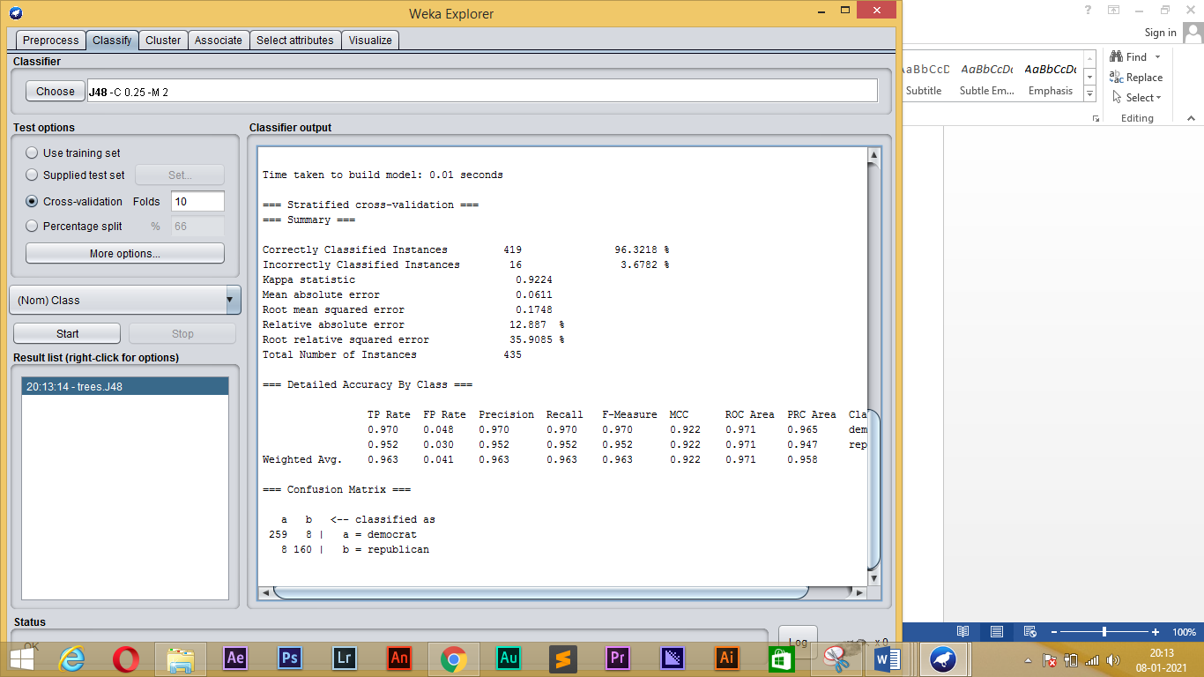

**WITH NB:**

== Run information ===

Scheme: weka.classifiers.bayes.NaiveBayes

Relation: vote

Instances: 435

Attributes: 17

handicapped-infants

water-project-cost-sharing

adoption-of-the-budget-resolution

physician-fee-freeze

el-salvador-aid

religious-groups-in-schools

anti-satellite-test-ban

aid-to-nicaraguan-contras

mx-missile

immigration

synfuels-corporation-cutback

education-spending

superfund-right-to-sue

crime

duty-free-exports

export-administration-act-south-africa

Class

Test mode: 10-fold cross-validation

=== Classifier model (full training set) ===

Naive Bayes Classifier

Class

Attribute democrat republican

(0.61) (0.39)

===============================================================

handicapped-infants

n 103.0 135.0

y 157.0 32.0

[total] 260.0 167.0

water-project-cost-sharing

n 120.0 74.0

y 121.0 76.0

[total] 241.0 150.0

adoption-of-the-budget-resolution

n 30.0 143.0

y 232.0 23.0

[total] 262.0 166.0

physician-fee-freeze

n 246.0 3.0

y 15.0 164.0

[total] 261.0 167.0

el-salvador-aid

n 201.0 9.0

y 56.0 158.0

[total] 257.0 167.0

religious-groups-in-schools

n 136.0 18.0

y 124.0 150.0

[total] 260.0 168.0

anti-satellite-test-ban

n 60.0 124.0

y 201.0 40.0

[total] 261.0 164.0

aid-to-nicaraguan-contras

n 46.0 134.0

y 219.0 25.0

[total] 265.0 159.0

mx-missile

n 61.0 147.0

y 189.0 20.0

[total] 250.0 167.0

immigration

n 140.0 74.0

y 125.0 93.0

[total] 265.0 167.0

synfuels-corporation-cutback

n 127.0 139.0

y 130.0 22.0

[total] 257.0 161.0

education-spending

n 214.0 21.0

y 37.0 136.0

[total] 251.0 157.0

superfund-right-to-sue

n 180.0 23.0

y 74.0 137.0

[total] 254.0 160.0

crime

n 168.0 4.0

y 91.0 159.0

[total] 259.0 163.0

duty-free-exports

n 92.0 143.0

y 161.0 15.0

[total] 253.0 158.0

export-administration-act-south-africa

n 13.0 51.0

y 174.0 97.0

[total] 187.0 148.0

Time taken to build model: 0.01 seconds

=== Stratified cross-validation ===

=== Summary ===

Correctly Classified Instances 392 90.1149 %

Incorrectly Classified Instances 43 9.8851 %

Kappa statistic 0.7949

Mean absolute error 0.0995

Root mean squared error 0.2977

Relative absolute error 20.9815 %

Root relative squared error 61.1406 %

Total Number of Instances 435

=== Detailed Accuracy By Class ===

TP Rate FP Rate Precision Recall F-Measure MCC ROC Area PRC Area Class

0.891 0.083 0.944 0.891 0.917 0.797 0.973 0.984 democrat

0.917 0.109 0.842 0.917 0.877 0.797 0.973 0.957 republican

Weighted Avg. 0.901 0.093 0.905 0.901 0.902 0.797 0.973 0.973

=== Confusion Matrix ===

a b <-- classified as

238 29 | a = democrat

14 154 | b = republican

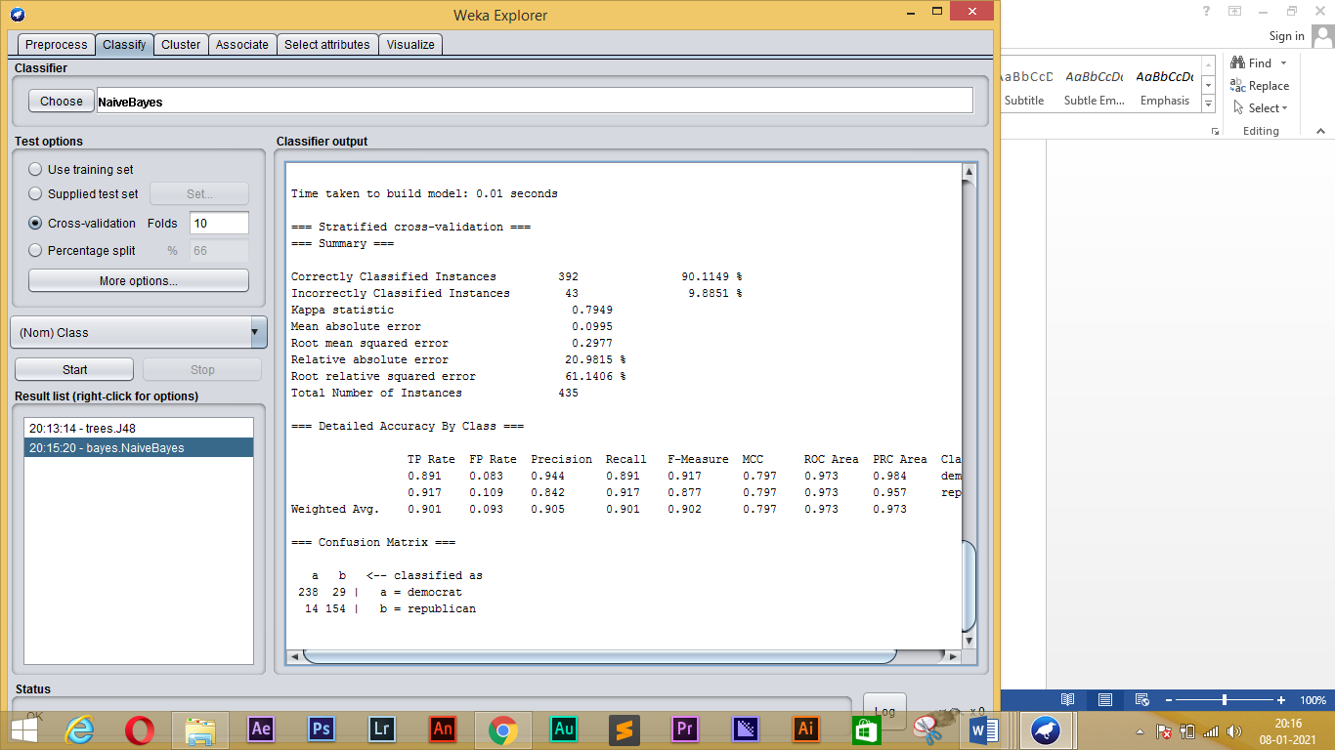

**WITH IBk:**

=== Run information ===

Scheme: weka.classifiers.lazy.IBk -K 1 -W 0 -A "weka.core.neighboursearch.LinearNNSearch -A \"weka.core.EuclideanDistance -R first-last\""

Relation: vote

Instances: 435

Attributes: 17

handicapped-infants

water-project-cost-sharing

adoption-of-the-budget-resolution

physician-fee-freeze

el-salvador-aid

religious-groups-in-schools

anti-satellite-test-ban

aid-to-nicaraguan-contras

mx-missile

immigration

synfuels-corporation-cutback

education-spending

superfund-right-to-sue

crime

duty-free-exports

export-administration-act-south-africa

Class

Test mode: 10-fold cross-validation

=== Classifier model (full training set) ===

IB1 instance-based classifier

using 1 nearest neighbour(s) for classification

Time taken to build model: 0 seconds

=== Stratified cross-validation ===

=== Summary ===

Correctly Classified Instances 402 92.4138 %

Incorrectly Classified Instances 33 7.5862 %

Kappa statistic 0.8423

Mean absolute error 0.073

Root mean squared error 0.242

Relative absolute error 15.3852 %

Root relative squared error 49.708 %

Total Number of Instances 435

=== Detailed Accuracy By Class ===

TP Rate FP Rate Precision Recall F-Measure MCC ROC Area PRC Area Class

0.914 0.060 0.961 0.914 0.937 0.844 0.965 0.973 democrat

0.940 0.086 0.873 0.940 0.905 0.844 0.965 0.934 republican

Weighted Avg. 0.924 0.070 0.927 0.924 0.925 0.844 0.965 0.958

=== Confusion Matrix ===

a b <-- classified as

244 23 | a = democrat

10 158 | b = republican

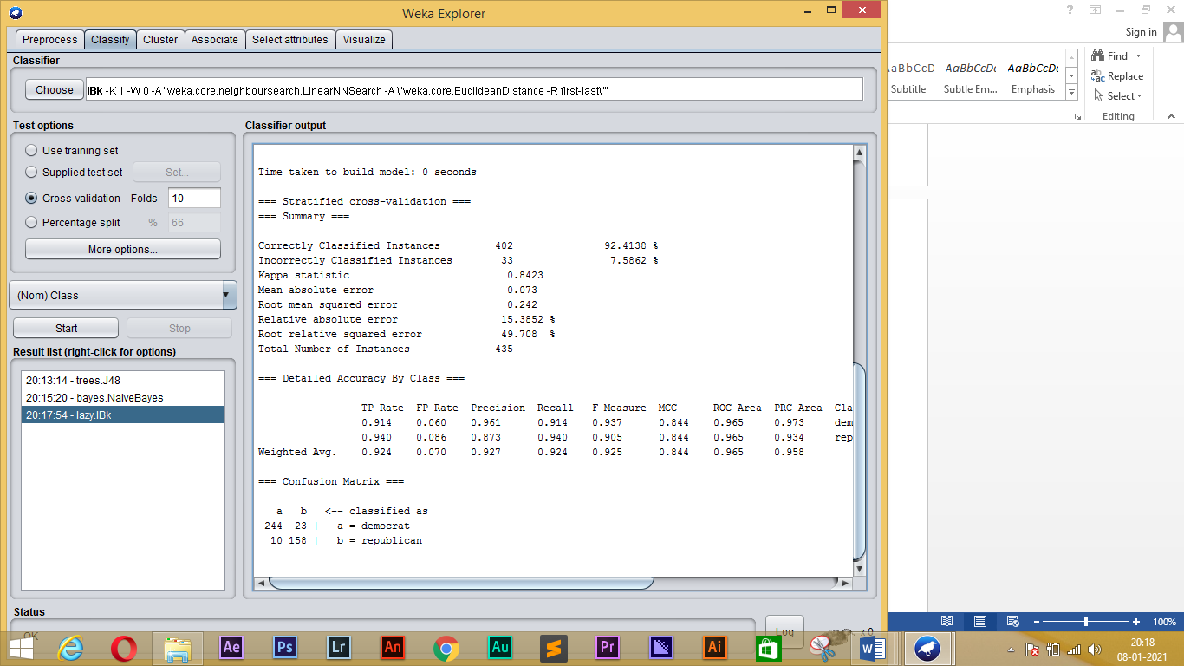

**3, Use AttributeSelectedClassifier (with WrapperSubsetEval, InfoGainAttributeEval and RankSearch) with classifiers J48, IBk and NB, evaluating with cross-validation**

**J48:**

=== Run information ===

Scheme: weka.classifiers.meta.AttributeSelectedClassifier -E "weka.attributeSelection.InfoGainAttributeEval " -S "weka.attributeSelection.Ranker -T -1.7976931348623157E308 -N -1" -W weka.classifiers.trees.J48 -- -C 0.25 -M 2

Relation: vote

Instances: 435

Attributes: 17

handicapped-infants

water-project-cost-sharing

adoption-of-the-budget-resolution

physician-fee-freeze

el-salvador-aid

religious-groups-in-schools

anti-satellite-test-ban

aid-to-nicaraguan-contras

mx-missile

immigration

synfuels-corporation-cutback

education-spending

superfund-right-to-sue

crime

duty-free-exports

export-administration-act-south-africa

Class

Test mode: 10-fold cross-validation

=== Classifier model (full training set) ===

AttributeSelectedClassifier:

=== Attribute Selection on all input data ===

Search Method:

Attribute ranking.

Attribute Evaluator (supervised, Class (nominal): 17 Class):

Information Gain Ranking Filter

Ranked attributes:

0.7078541 4 physician-fee-freeze

0.4185726 3 adoption-of-the-budget-resolution

0.4028397 5 el-salvador-aid

0.34036 12 education-spending

0.3123121 14 crime

0.3095576 8 aid-to-nicaraguan-contras

0.2856444 9 mx-missile

0.2121705 13 superfund-right-to-sue

0.2013666 15 duty-free-exports

0.1902427 7 anti-satellite-test-ban

0.1404643 6 religious-groups-in-schools

0.1211834 1 handicapped-infants

0.1007458 11 synfuels-corporation-cutback

0.0529956 16 export-administration-act-south-africa

0.0049097 10 immigration

0.0000117 2 water-project-cost-sharing

Selected attributes: 4,3,5,12,14,8,9,13,15,7,6,1,11,16,10,2 : 16

Header of reduced data:

@relation 'vote-weka.filters.unsupervised.attribute.Remove-V-R4,3,5,12,14,8-9,13,15,7,6,1,11,16,10,2,17'

@attribute handicapped-infants {n,y}

@attribute water-project-cost-sharing {n,y}

@attribute adoption-of-the-budget-resolution {n,y}

@attribute physician-fee-freeze {n,y}

@attribute el-salvador-aid {n,y}

@attribute religious-groups-in-schools {n,y}

@attribute anti-satellite-test-ban {n,y}

@attribute aid-to-nicaraguan-contras {n,y}

@attribute mx-missile {n,y}

@attribute immigration {n,y}

@attribute synfuels-corporation-cutback {n,y}

@attribute education-spending {n,y}

@attribute superfund-right-to-sue {n,y}

@attribute crime {n,y}

@attribute duty-free-exports {n,y}

@attribute export-administration-act-south-africa {n,y}

@attribute Class {democrat,republican}

@data

Classifier Model

J48 pruned tree

------------------

physician-fee-freeze = n: democrat (253.41/3.75)

physician-fee-freeze = y

| synfuels-corporation-cutback = n: republican (145.71/4.0)

| synfuels-corporation-cutback = y

| | mx-missile = n

| | | adoption-of-the-budget-resolution = n: republican (22.61/3.32)

| | | adoption-of-the-budget-resolution = y

| | | | anti-satellite-test-ban = n: democrat (5.04/0.02)

| | | | anti-satellite-test-ban = y: republican (2.21)

| | mx-missile = y: democrat (6.03/1.03)

Number of Leaves : 6

Size of the tree : 11

Time taken to build model: 0.04 seconds

=== Stratified cross-validation ===

=== Summary ===

Correctly Classified Instances 419 96.3218 %

Incorrectly Classified Instances 16 3.6782 %

Kappa statistic 0.9224

Mean absolute error 0.0611

Root mean squared error 0.1748

Relative absolute error 12.887 %

Root relative squared error 35.9085 %

Total Number of Instances 435

=== Detailed Accuracy By Class ===

TP Rate FP Rate Precision Recall F-Measure MCC ROC Area PRC Area Class

0.970 0.048 0.970 0.970 0.970 0.922 0.971 0.965 democrat

0.952 0.030 0.952 0.952 0.952 0.922 0.971 0.947 republican

Weighted Avg. 0.963 0.041 0.963 0.963 0.963 0.922 0.971 0.958

=== Confusion Matrix ===

a b <-- classified as

259 8 | a = democrat

8 160 | b = republican

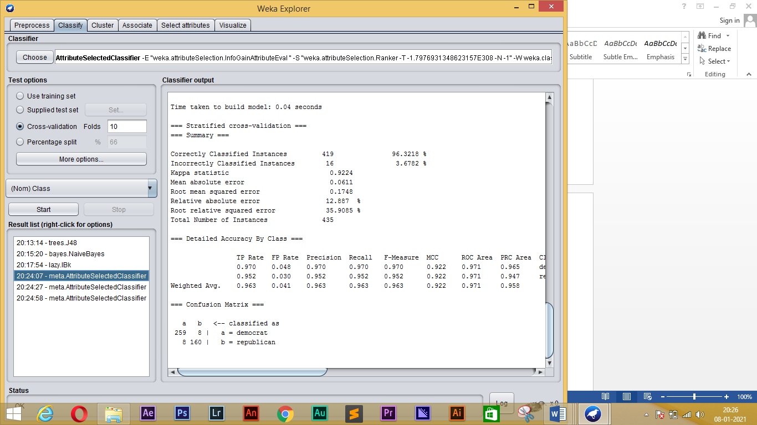

**NB:**

== Run information ===

Scheme: weka.classifiers.meta.AttributeSelectedClassifier -E "weka.attributeSelection.InfoGainAttributeEval " -S "weka.attributeSelection.Ranker -T -1.7976931348623157E308 -N -1" -W weka.classifiers.bayes.NaiveBayes

Relation: vote

Instances: 435

Attributes: 17

handicapped-infants

water-project-cost-sharing

adoption-of-the-budget-resolution

physician-fee-freeze

el-salvador-aid

religious-groups-in-schools

anti-satellite-test-ban

aid-to-nicaraguan-contras

mx-missile

immigration

synfuels-corporation-cutback

education-spending

superfund-right-to-sue

crime

duty-free-exports

export-administration-act-south-africa

Class

Test mode: 10-fold cross-validation

=== Classifier model (full training set) ===

AttributeSelectedClassifier:

=== Attribute Selection on all input data ===

Search Method:

Attribute ranking.

Attribute Evaluator (supervised, Class (nominal): 17 Class):

Information Gain Ranking Filter

Ranked attributes:

0.7078541 4 physician-fee-freeze

0.4185726 3 adoption-of-the-budget-resolution

0.4028397 5 el-salvador-aid

0.34036 12 education-spending

0.3123121 14 crime

0.3095576 8 aid-to-nicaraguan-contras

0.2856444 9 mx-missile

0.2121705 13 superfund-right-to-sue

0.2013666 15 duty-free-exports

0.1902427 7 anti-satellite-test-ban

0.1404643 6 religious-groups-in-schools

0.1211834 1 handicapped-infants

0.1007458 11 synfuels-corporation-cutback

0.0529956 16 export-administration-act-south-africa

0.0049097 10 immigration

0.0000117 2 water-project-cost-sharing

Selected attributes: 4,3,5,12,14,8,9,13,15,7,6,1,11,16,10,2 : 16

Header of reduced data:

@relation 'vote-weka.filters.unsupervised.attribute.Remove-V-R4,3,5,12,14,8-9,13,15,7,6,1,11,16,10,2,17'

@attribute handicapped-infants {n,y}

@attribute water-project-cost-sharing {n,y}

@attribute adoption-of-the-budget-resolution {n,y}

@attribute physician-fee-freeze {n,y}

@attribute el-salvador-aid {n,y}

@attribute religious-groups-in-schools {n,y}

@attribute anti-satellite-test-ban {n,y}

@attribute aid-to-nicaraguan-contras {n,y}

@attribute mx-missile {n,y}

@attribute immigration {n,y}

@attribute synfuels-corporation-cutback {n,y}

@attribute education-spending {n,y}

@attribute superfund-right-to-sue {n,y}

@attribute crime {n,y}

@attribute duty-free-exports {n,y}

@attribute export-administration-act-south-africa {n,y}

@attribute Class {democrat,republican}

@data

Classifier Model

Naive Bayes Classifier

Class

Attribute democrat republican

(0.61) (0.39)

===============================================================

handicapped-infants

n 103.0 135.0

y 157.0 32.0

[total] 260.0 167.0

water-project-cost-sharing

n 120.0 74.0

y 121.0 76.0

[total] 241.0 150.0

adoption-of-the-budget-resolution

n 30.0 143.0

y 232.0 23.0

[total] 262.0 166.0

physician-fee-freeze

n 246.0 3.0

y 15.0 164.0

[total] 261.0 167.0

el-salvador-aid

n 201.0 9.0

y 56.0 158.0

[total] 257.0 167.0

religious-groups-in-schools

n 136.0 18.0

y 124.0 150.0

[total] 260.0 168.0

anti-satellite-test-ban

n 60.0 124.0

y 201.0 40.0

[total] 261.0 164.0

aid-to-nicaraguan-contras

n 46.0 134.0

y 219.0 25.0

[total] 265.0 159.0

mx-missile

n 61.0 147.0

y 189.0 20.0

[total] 250.0 167.0

immigration

n 140.0 74.0

y 125.0 93.0

[total] 265.0 167.0

synfuels-corporation-cutback

n 127.0 139.0

y 130.0 22.0

[total] 257.0 161.0

education-spending

n 214.0 21.0

y 37.0 136.0

[total] 251.0 157.0

superfund-right-to-sue

n 180.0 23.0

y 74.0 137.0

[total] 254.0 160.0

crime

n 168.0 4.0

y 91.0 159.0

[total] 259.0 163.0

duty-free-exports

n 92.0 143.0

y 161.0 15.0

[total] 253.0 158.0

export-administration-act-south-africa

n 13.0 51.0

y 174.0 97.0

[total] 187.0 148.0

Time taken to build model: 0.01 seconds

=== Stratified cross-validation ===

=== Summary ===

Correctly Classified Instances 392 90.1149 %

Incorrectly Classified Instances 43 9.8851 %

Kappa statistic 0.7949

Mean absolute error 0.0995

Root mean squared error 0.2977

Relative absolute error 20.9815 %

Root relative squared error 61.1406 %

Total Number of Instances 435

=== Detailed Accuracy By Class ===

TP Rate FP Rate Precision Recall F-Measure MCC ROC Area PRC Area Class

0.891 0.083 0.944 0.891 0.917 0.797 0.973 0.984 democrat

0.917 0.109 0.842 0.917 0.877 0.797 0.973 0.957 republican

Weighted Avg. 0.901 0.093 0.905 0.901 0.902 0.797 0.973 0.973

=== Confusion Matrix ===

a b <-- classified as

238 29 | a = democrat

14 154 | b = republican

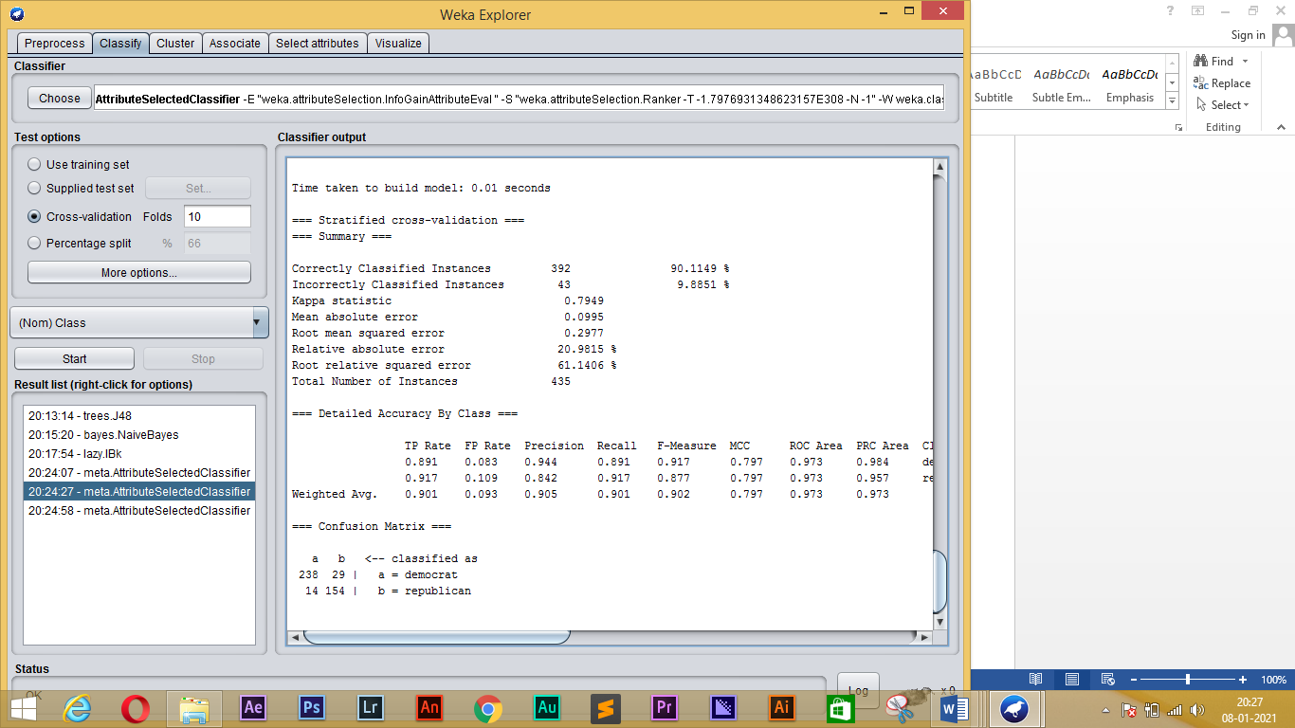

**IBk:**

=== Run information ===

Scheme: weka.classifiers.meta.AttributeSelectedClassifier -E "weka.attributeSelection.InfoGainAttributeEval " -S "weka.attributeSelection.Ranker -T -1.7976931348623157E308 -N -1" -W weka.classifiers.lazy.IBk -- -K 1 -W 0 -A "weka.core.neighboursearch.LinearNNSearch -A \"weka.core.EuclideanDistance -R first-last\""

Relation: vote

Instances: 435

Attributes: 17

handicapped-infants

water-project-cost-sharing

adoption-of-the-budget-resolution

physician-fee-freeze

el-salvador-aid

religious-groups-in-schools

anti-satellite-test-ban

aid-to-nicaraguan-contras

mx-missile

immigration

synfuels-corporation-cutback

education-spending

superfund-right-to-sue

crime

duty-free-exports

export-administration-act-south-africa

Class

Test mode: 10-fold cross-validation

=== Classifier model (full training set) ===

AttributeSelectedClassifier:

=== Attribute Selection on all input data ===

Search Method:

Attribute ranking.

Attribute Evaluator (supervised, Class (nominal): 17 Class):

Information Gain Ranking Filter

Ranked attributes:

0.7078541 4 physician-fee-freeze

0.4185726 3 adoption-of-the-budget-resolution

0.4028397 5 el-salvador-aid

0.34036 12 education-spending

0.3123121 14 crime

0.3095576 8 aid-to-nicaraguan-contras

0.2856444 9 mx-missile

0.2121705 13 superfund-right-to-sue

0.2013666 15 duty-free-exports

0.1902427 7 anti-satellite-test-ban

0.1404643 6 religious-groups-in-schools

0.1211834 1 handicapped-infants

0.1007458 11 synfuels-corporation-cutback

0.0529956 16 export-administration-act-south-africa

0.0049097 10 immigration

0.0000117 2 water-project-cost-sharing

Selected attributes: 4,3,5,12,14,8,9,13,15,7,6,1,11,16,10,2 : 16

Header of reduced data:

@relation 'vote-weka.filters.unsupervised.attribute.Remove-V-R4,3,5,12,14,8-9,13,15,7,6,1,11,16,10,2,17'

@attribute handicapped-infants {n,y}

@attribute water-project-cost-sharing {n,y}

@attribute adoption-of-the-budget-resolution {n,y}

@attribute physician-fee-freeze {n,y}

@attribute el-salvador-aid {n,y}

@attribute religious-groups-in-schools {n,y}

@attribute anti-satellite-test-ban {n,y}

@attribute aid-to-nicaraguan-contras {n,y}

@attribute mx-missile {n,y}

@attribute immigration {n,y}

@attribute synfuels-corporation-cutback {n,y}

@attribute education-spending {n,y}

@attribute superfund-right-to-sue {n,y}

@attribute crime {n,y}

@attribute duty-free-exports {n,y}

@attribute export-administration-act-south-africa {n,y}

@attribute Class {democrat,republican}

@data

Classifier Model

IB1 instance-based classifier

using 1 nearest neighbour(s) for classification

Time taken to build model: 0.01 seconds

=== Stratified cross-validation ===

=== Summary ===

Correctly Classified Instances 402 92.4138 %

Incorrectly Classified Instances 33 7.5862 %

Kappa statistic 0.8423

Mean absolute error 0.073

Root mean squared error 0.242

Relative absolute error 15.3852 %

Root relative squared error 49.708 %

Total Number of Instances 435

=== Detailed Accuracy By Class ===

TP Rate FP Rate Precision Recall F-Measure MCC ROC Area PRC Area Class

0.914 0.060 0.961 0.914 0.937 0.844 0.965 0.973 democrat

0.940 0.086 0.873 0.940 0.905 0.844 0.965 0.934 republican

Weighted Avg. 0.924 0.070 0.927 0.924 0.925 0.844 0.965 0.958

=== Confusion Matrix ===

a b <-- classified as

244 23 | a = democrat

10 158 | b = republican

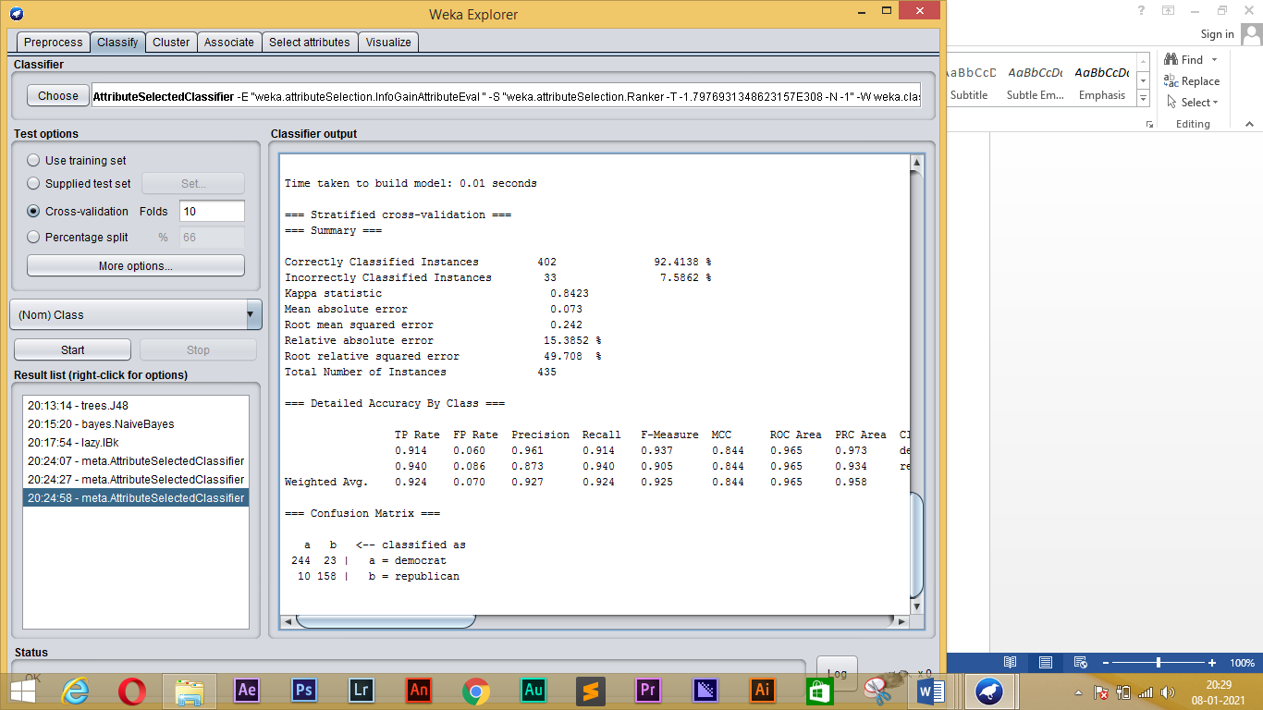

**Sampling a dataset:**

**1, Load the letter dataset and examine a particular (numeric) attribute:**

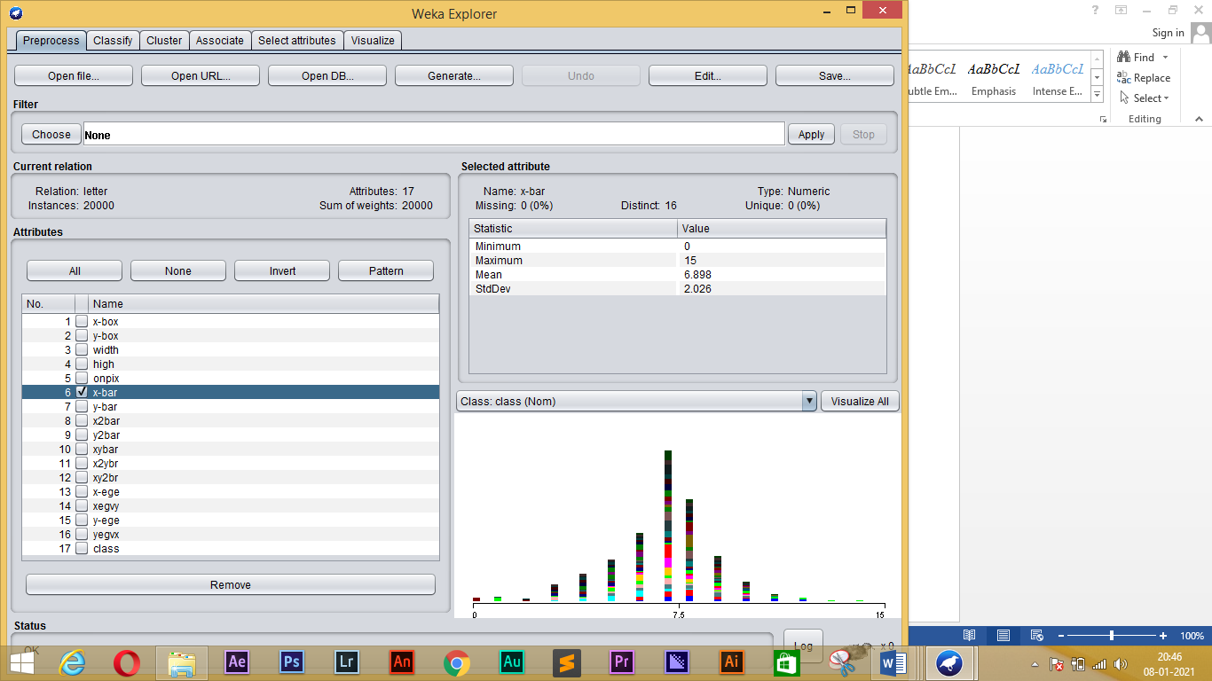

**2, Apply the Resample filter to select half the dataset**

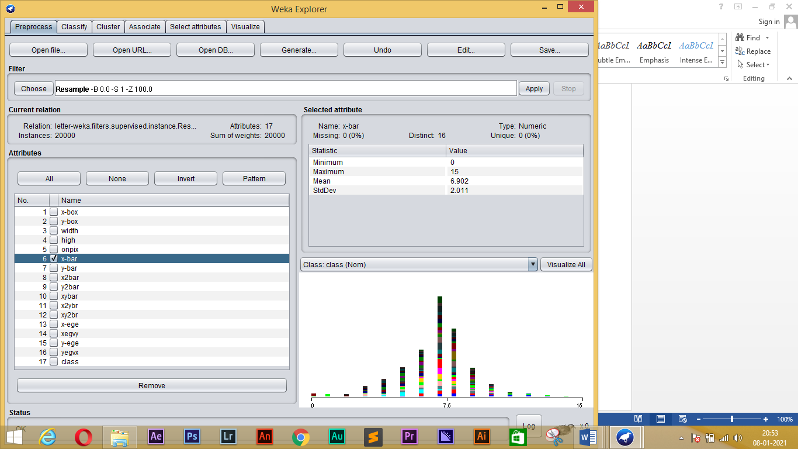

**RESULT:**

Data Processing for data mining using WEKA Tool is performed.

**EXPERIMENT-5**

**AIM**:

To perform Clustering using WEKA Tool.

**PROCEDURE**:

1. Go to the WEKA Explorer environment and load the training file “iris.arff”. Remove the class attribute using the preprocessing dialog. Go to the clustering dialog.

* Cluster the iris dataset using the k-Means Clustering algorithm with k=5. Hand in the result given by WEKA (Cluster mean and standard deviation).
* Cluster the iris dataset using the k-Means Clustering algorithm with k=3 and k=4 and with ten different values of the seed parameter, using the option: Classes to cluster evaluation and and store the results on an excel file. Compute the mean of the two different k values for the k-Means
* Visualize the cluster mean values and standard deviation for - sepallength versus sepalwidth – petallength versus petalwidth. Don’t erase the result of the k-Means algorithm.

2. Using the EM algorithm with the iris dataset, try to run the EM algorithm, with the automatic estimation of the number of clusters. Then, try to repeat the experiments of the previous section with the EM algorithm. Compare the results.

3. Create an “arff”-file containing the data points as given below.

t1 = (4, 2, 3, 5, 2, 2, 2, 1)

t2 = (3, 2, 5, 4, 3, 2, 1, 4)

t3 = (1, 3, 3, 5, 2, 3, 2, 1)

t4 = (4, 2, 0, 5, 2, 2, 2, 1)

t5 = (3, 2, 3, 4, 3, 2, 1, 4)

t6 = (2, 5, 3, 5, 2, 2, 2, 1)

t7 = (4, 1, 3, 7, 2, 1, 2, 1)

t8 = (3, 1, 5, 4, 3, 2, 1, 4)

t9 = (2, 5, 2, 5, 2, 5, 2, 1)

Cluster the above data file using K-means and EM with k=2 and k=3 clusters.

4. Using Cobweb algorithm, run the algorithm on the iris dataset. First you must use the option: Using training set and then using the option: **Classes to cluster evaluation**. For both the options visualize the tree obtained. What is the difference? How is the behaviour of the algorithm? In your opinion, what is the factor that influences the algorithm?

5. Download the dataset http://www.upo.es/eps/bigs/dataSet/Lymphoma96x4026+9classes.arff.

k-means and EM (with Classes to cluster evaluation option) change the number of cluster from

10 to 20, step equal to 1, and store the Incorrectly clustered instances for both the algorithms

**OUTPUT:**

**1, LOAD THE IRIS DATASET:**

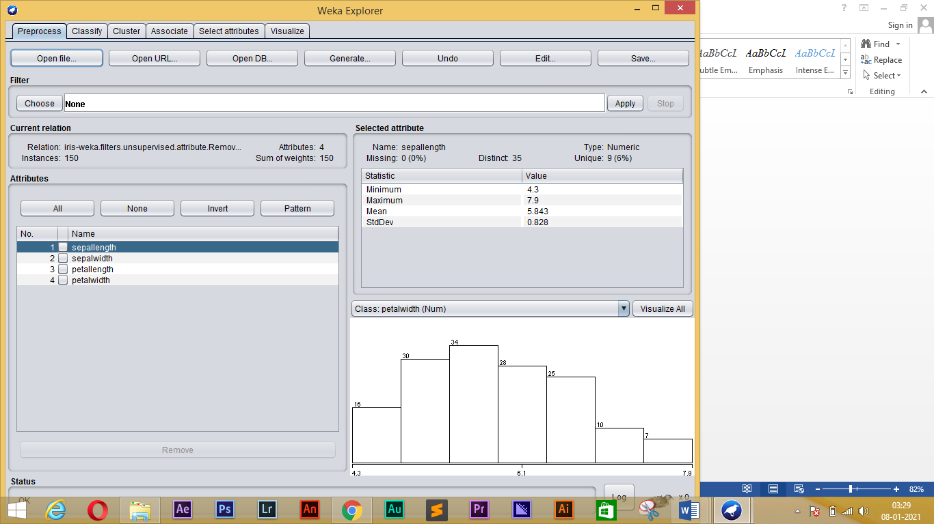

**2, K – MEANS ALGORITHM WITH K = 5 :**

=== Run information ===

Scheme: weka.clusterers.SimpleKMeans -init 0 -max-candidates 100 -periodic-pruning 10000 -min-density 2.0 -t1 -1.25 -t2 -1.0 -N 5 -A "weka.core.EuclideanDistance -R first-last" -I 500 -num-slots 1 -S 10

Relation: iris-weka.filters.unsupervised.attribute.Remove-R5

Instances: 150

Attributes: 4

sepallength

sepalwidth

petallength

petalwidth

Test mode: evaluate on training data

=== Clustering model (full training set) ===

kMeans

======

Number of iterations: 9

Within cluster sum of squared errors: 5.130784647061167

Initial starting points (random):

Cluster 0: 6.1,2.9,4.7,1.4

Cluster 1: 6.2,2.9,4.3,1.3

Cluster 2: 6.9,3.1,5.1,2.3

Cluster 3: 5.5,4.2,1.4,0.2

Cluster 4: 6.9,3.1,4.9,1.5

Missing values globally replaced with mean/mode

Final cluster centroids:

Cluster#

Attribute Full Data 0 1 2 3 4

(150.0) (27.0) (26.0) (27.0) (50.0) (20.0)

===============================================================================

sepallength 5.8433 6.0296 5.55 6.9667 5.006 6.55

sepalwidth 3.054 2.7556 2.5808 3.137 3.418 3.05

petallength 3.7587 4.9444 3.9269 5.8852 1.464 4.805

petalwidth 1.1987 1.7037 1.2 2.2 0.244 1.55

Time taken to build model (full training data) : 0.03 seconds

=== Model and evaluation on training set ===

Clustered Instances

0 27 ( 18%)

1 26 ( 17%)

2 27 ( 18%)

3 50 ( 33%)

4 20 ( 13%)

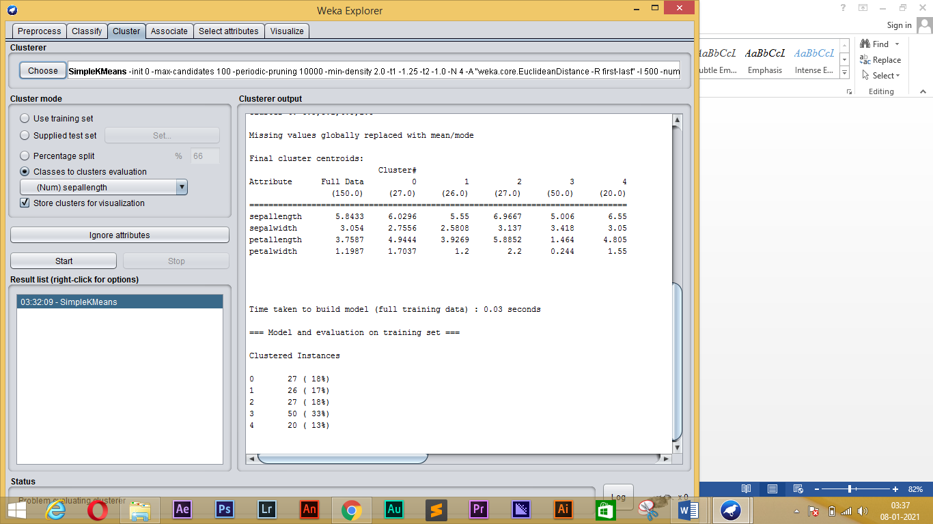

**3, K=3:**

=== Run information ===

Scheme: weka.clusterers.SimpleKMeans -init 0 -max-candidates 100 -periodic-pruning 10000 -min-density 2.0 -t1 -1.25 -t2 -1.0 -N 3 -A "weka.core.EuclideanDistance -R first-last" -I 500 -num-slots 1 -S 1

Relation: iris

Instances: 150

Attributes: 5

sepallength

sepalwidth

petallength

petalwidth

Ignored:

class

Test mode: Classes to clusters evaluation on training data

=== Clustering model (full training set) ===

kMeans

======

Number of iterations: 8

Within cluster sum of squared errors: 6.9981140048267605

Initial starting points (random):

Cluster 0: 7.7,3,6.1,2.3

Cluster 1: 6.3,2.5,4.9,1.5

Cluster 2: 6.4,2.7,5.3,1.9

Missing values globally replaced with mean/mode

Final cluster centroids:

Cluster#

Attribute Full Data 0 1 2

(150.0) (39.0) (50.0) (61.0)

=========================================================

sepallength 5.8433 6.8462 5.006 5.8885

sepalwidth 3.054 3.0821 3.418 2.7377

petallength 3.7587 5.7026 1.464 4.3967

petalwidth 1.1987 2.0795 0.244 1.418

Time taken to build model (full training data) : 0.01 seconds

=== Model and evaluation on training set ===

Clustered Instances

0 39 ( 26%)

1 50 ( 33%)

2 61 ( 41%)

Class attribute: class

Classes to Clusters:

0 1 2 <-- assigned to cluster

0 50 0 | Iris-setosa

3 0 47 | Iris-versicolor

36 0 14 | Iris-virginica

Cluster 0 <-- Iris-virginica

Cluster 1 <-- Iris-setosa

Cluster 2 <-- Iris-versicolor

Incorrectly clustered instances : 17.0 11.3333 %

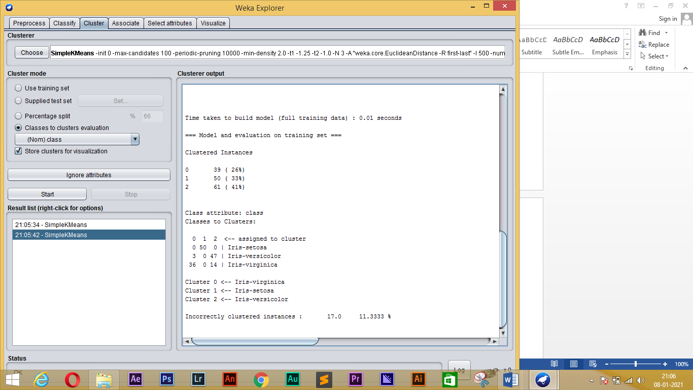

**4, K=4:**

=== Run information ===

Scheme: weka.clusterers.SimpleKMeans -init 0 -max-candidates 100 -periodic-pruning 10000 -min-density 2.0 -t1 -1.25 -t2 -1.0 -N 4 -A "weka.core.EuclideanDistance -R first-last" -I 500 -num-slots 1 -S 5

Relation: iris

Instances: 150

Attributes: 5

sepallength

sepalwidth

petallength

petalwidth

Ignored:

class

Test mode: Classes to clusters evaluation on training data

=== Clustering model (full training set) ===

kMeans

======

Number of iterations: 7

Within cluster sum of squared errors: 5.532831003081898

Initial starting points (random):

Cluster 0: 6.4,3.1,5.5,1.8

Cluster 1: 5.6,2.7,4.2,1.3

Cluster 2: 6.7,3.1,4.7,1.5

Cluster 3: 5,3.2,1.2,0.2

Missing values globally replaced with mean/mode

Final cluster centroids:

Cluster#

Attribute Full Data 0 1 2 3

(150.0) (29.0) (29.0) (42.0) (50.0)

====================================================================

sepallength 5.8433 6.9586 5.5828 6.25 5.006

sepalwidth 3.054 3.1345 2.569 2.9 3.418

petallength 3.7587 5.8552 4.0034 4.8738 1.464

petalwidth 1.1987 2.1724 1.231 1.6405 0.244

Time taken to build model (full training data) : 0.01 seconds

=== Model and evaluation on training set ===

Clustered Instances

0 29 ( 19%)

1 29 ( 19%)

2 42 ( 28%)

3 50 ( 33%)

Class attribute: class

Classes to Clusters:

0 1 2 3 <-- assigned to cluster

0 0 0 50 | Iris-setosa

0 27 23 0 | Iris-versicolor

29 2 19 0 | Iris-virginica

Cluster 0 <-- Iris-virginica

Cluster 1 <-- Iris-versicolor

Cluster 2 <-- No class

Cluster 3 <-- Iris-setosa

Incorrectly clustered instances : 44.0 29.3333 %

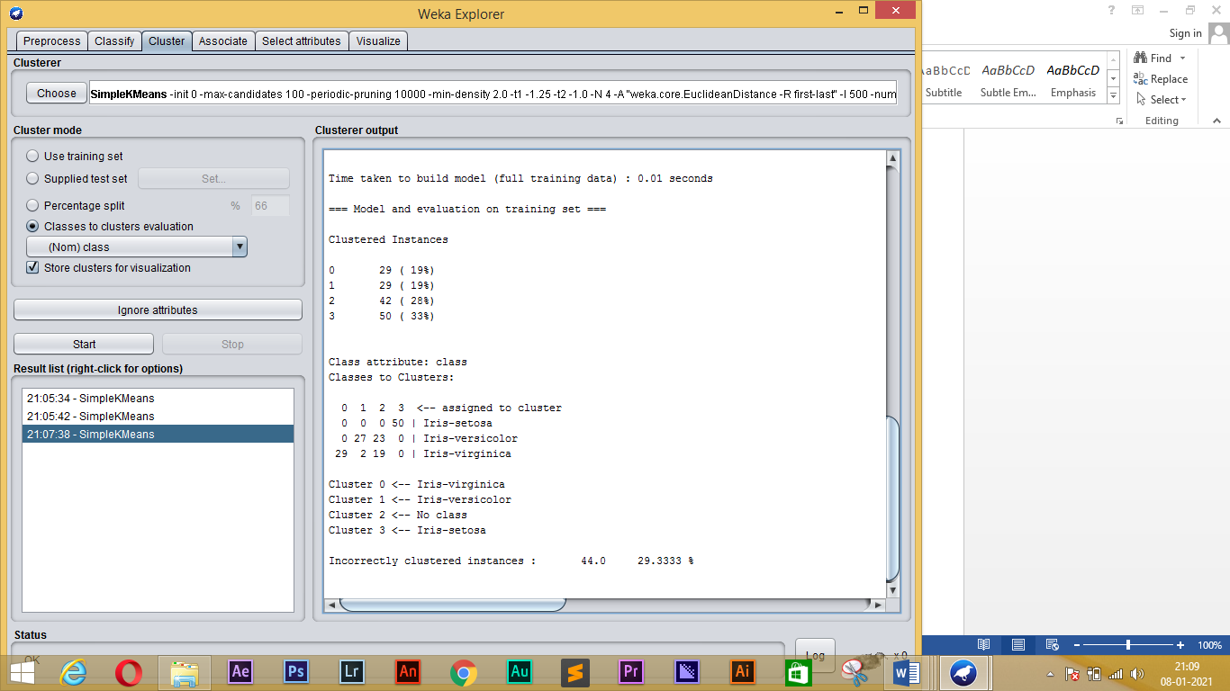

**5, Visualize the cluster mean values and standard deviation for - sepallength versus sepalwidth – petallength versus petalwidth:**

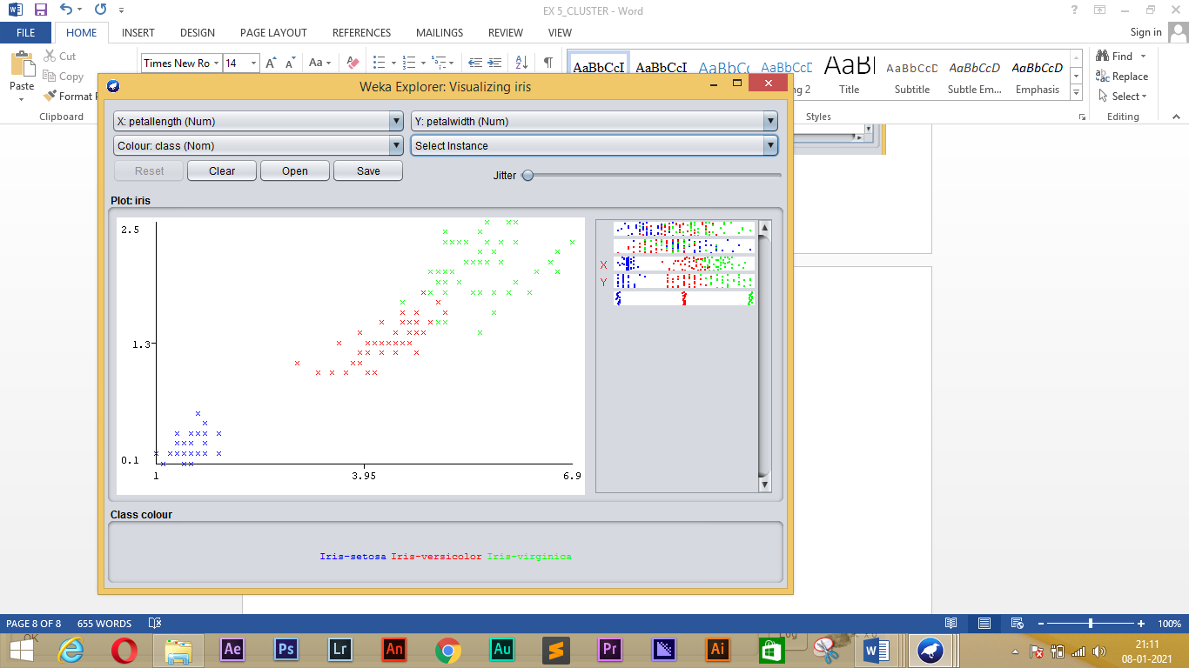

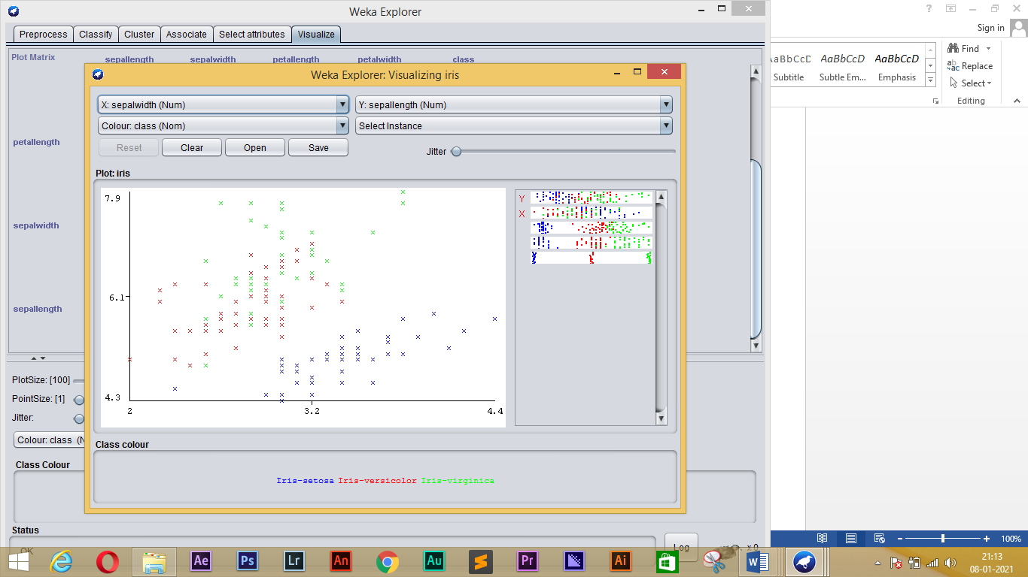

**Using the EM algorithm with the iris dataset, try to run the EM algorithm, with the automatic estimation of the number of clusters. Then, try to repeat the experiments of the previous section with the EM algorithm**

**K=5:**

=== Run information ===

Scheme: weka.clusterers.EM -I 100 -N 5 -X 10 -max -1 -ll-cv 1.0E-6 -ll-iter 1.0E-6 -M 1.0E-6 -K 10 -num-slots 1 -S 100

Relation: iris

Instances: 150

Attributes: 5

sepallength

sepalwidth

petallength

petalwidth

Ignored:

class

Test mode: Classes to clusters evaluation on training data

=== Clustering model (full training set) ===

EM

==

Number of clusters: 5

Number of iterations performed: 16

Cluster

Attribute 0 1 2 3 4

(0.18) (0.23) (0.28) (0.15) (0.15)

======================================================

sepallength

mean 4.7748 6.8585 6.1613 5.2823 5.5432

std. dev. 0.2405 0.5228 0.4138 0.2407 0.3159

sepalwidth

mean 3.1789 3.0862 2.8547 3.7037 2.5786

std. dev. 0.2599 0.2891 0.2687 0.2857 0.2512

petallength

mean 1.4194 5.7859 4.7484 1.5173 3.863

std. dev. 0.1692 0.4745 0.3193 0.1592 0.3516

petalwidth

mean 0.1948 2.1327 1.5757 0.3028 1.1696

std. dev. 0.0557 0.2359 0.2196 0.1212 0.1351

Time taken to build model (full training data) : 0.12 seconds

=== Model and evaluation on training set ===

Clustered Instances

0 28 ( 19%)

1 35 ( 23%)

2 42 ( 28%)

3 22 ( 15%)

4 23 ( 15%)

Log likelihood: -1.60803

Class attribute: class

Classes to Clusters:

0 1 2 3 4 <-- assigned to cluster

28 0 0 22 0 | Iris-setosa

0 0 27 0 23 | Iris-versicolor

0 35 15 0 0 | Iris-virginica

Cluster 0 <-- Iris-setosa

Cluster 1 <-- Iris-virginica

Cluster 2 <-- Iris-versicolor

Cluster 3 <-- No class

Cluster 4 <-- No class

Incorrectly clustered instances : 60.0 40 %

**K=4:**

=== Run information ===

Scheme: weka.clusterers.EM -I 100 -N 4 -X 10 -max -1 -ll-cv 1.0E-6 -ll-iter 1.0E-6 -M 1.0E-6 -K 10 -num-slots 1 -S 100

Relation: iris

Instances: 150

Attributes: 5

sepallength

sepalwidth

petallength

petalwidth

Ignored:

class

Test mode: Classes to clusters evaluation on training data

=== Clustering model (full training set) ===

EM

==

Number of clusters: 4

Number of iterations performed: 18

Cluster

Attribute 0 1 2 3

(0.33) (0.28) (0.23) (0.15)

==============================================

sepallength

mean 5.006 6.1614 6.8586 5.5432

std. dev. 0.3489 0.4137 0.5228 0.3159

sepalwidth

mean 3.418 2.8547 3.0862 2.5786

std. dev. 0.3772 0.2687 0.2891 0.2512

petallength

mean 1.464 4.7484 5.7859 3.863

std. dev. 0.1718 0.3193 0.4745 0.3516

petalwidth

mean 0.244 1.5757 2.1327 1.1696

std. dev. 0.1061 0.2196 0.2359 0.1351

Time taken to build model (full training data) : 0.08 seconds

=== Model and evaluation on training set ===

Clustered Instances

0 50 ( 33%)

1 42 ( 28%)

2 35 ( 23%)

3 23 ( 15%)

Log likelihood: -1.7728

Class attribute: class

Classes to Clusters:

0 1 2 3 <-- assigned to cluster

50 0 0 0 | Iris-setosa

0 27 0 23 | Iris-versicolor

0 15 35 0 | Iris-virginica

Cluster 0 <-- Iris-setosa

Cluster 1 <-- Iris-versicolor

Cluster 2 <-- Iris-virginica

Cluster 3 <-- No class

Incorrectly clustered instances : 38.0 25.3333 %

**K=3:**

=== Run information ===

Scheme: weka.clusterers.EM -I 100 -N 3 -X 10 -max -1 -ll-cv 1.0E-6 -ll-iter 1.0E-6 -M 1.0E-6 -K 10 -num-slots 1 -S 100

Relation: iris

Instances: 150

Attributes: 5

sepallength

sepalwidth

petallength

petalwidth

Ignored:

class

Test mode: Classes to clusters evaluation on training data

=== Clustering model (full training set) ===

EM

==

Number of clusters: 3

Number of iterations performed: 10

Cluster

Attribute 0 1 2

(0.41) (0.33) (0.25)

======================================

sepallength

mean 5.9275 5.006 6.8085

std. dev. 0.4817 0.3489 0.5339

sepalwidth

mean 2.7503 3.418 3.0709

std. dev. 0.2956 0.3772 0.2867

petallength

mean 4.4057 1.464 5.7233

std. dev. 0.5254 0.1718 0.4991

petalwidth

mean 1.4131 0.244 2.1055

std. dev. 0.2627 0.1061 0.2456

Time taken to build model (full training data) : 0.04 seconds

=== Model and evaluation on training set ===

Clustered Instances

0 64 ( 43%)

1 50 ( 33%)

2 36 ( 24%)

Log likelihood: -2.055

Class attribute: class

Classes to Clusters:

0 1 2 <-- assigned to cluster

0 50 0 | Iris-setosa

50 0 0 | Iris-versicolor

14 0 36 | Iris-virginica

Cluster 0 <-- Iris-versicolor

Cluster 1 <-- Iris-setosa

Cluster 2 <-- Iris-virginica

Incorrectly clustered instances : 14.0 9.3333 %

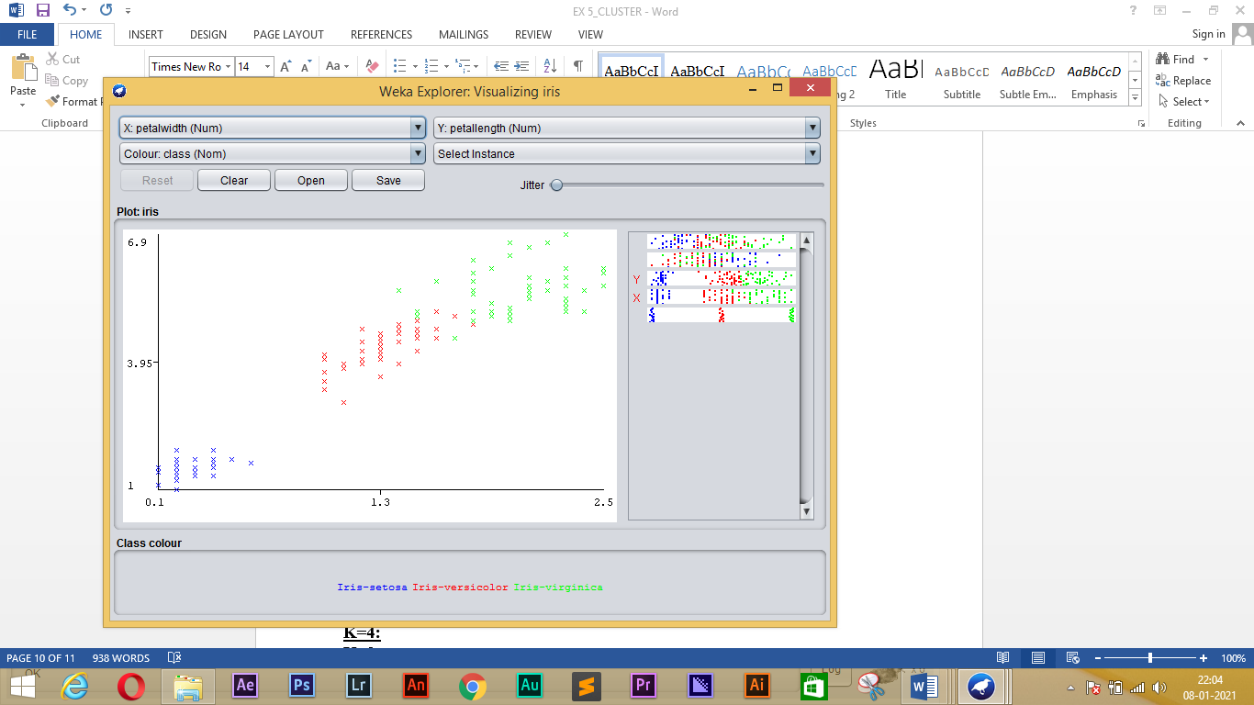

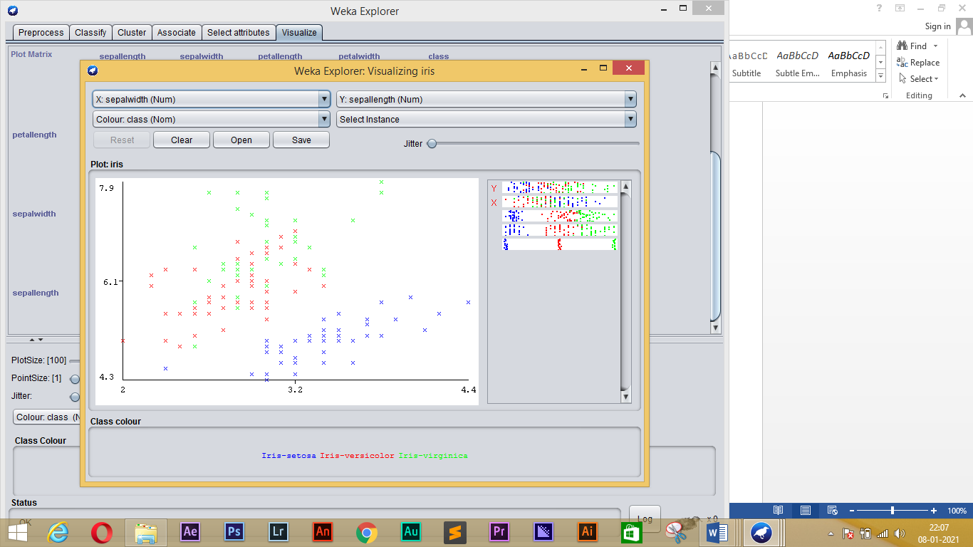

**Create an “arff”-file containing the data points as given below.**

**t1 = (4, 2, 3, 5, 2, 2, 2, 1)**

**t2 = (3, 2, 5, 4, 3, 2, 1, 4)**

**t3 = (1, 3, 3, 5, 2, 3, 2, 1)**

**t4 = (4, 2, 0, 5, 2, 2, 2, 1)**

**t5 = (3, 2, 3, 4, 3, 2, 1, 4)**

**t6 = (2, 5, 3, 5, 2, 2, 2, 1)**

**t7 = (4, 1, 3, 7, 2, 1, 2, 1)**

**t8 = (3, 1, 5, 4, 3, 2, 1, 4)**

**t9 = (2, 5, 2, 5, 2, 5, 2, 1)**

**Cluster the above data file using K-means and EM with k=2 and k=3 clusters.**

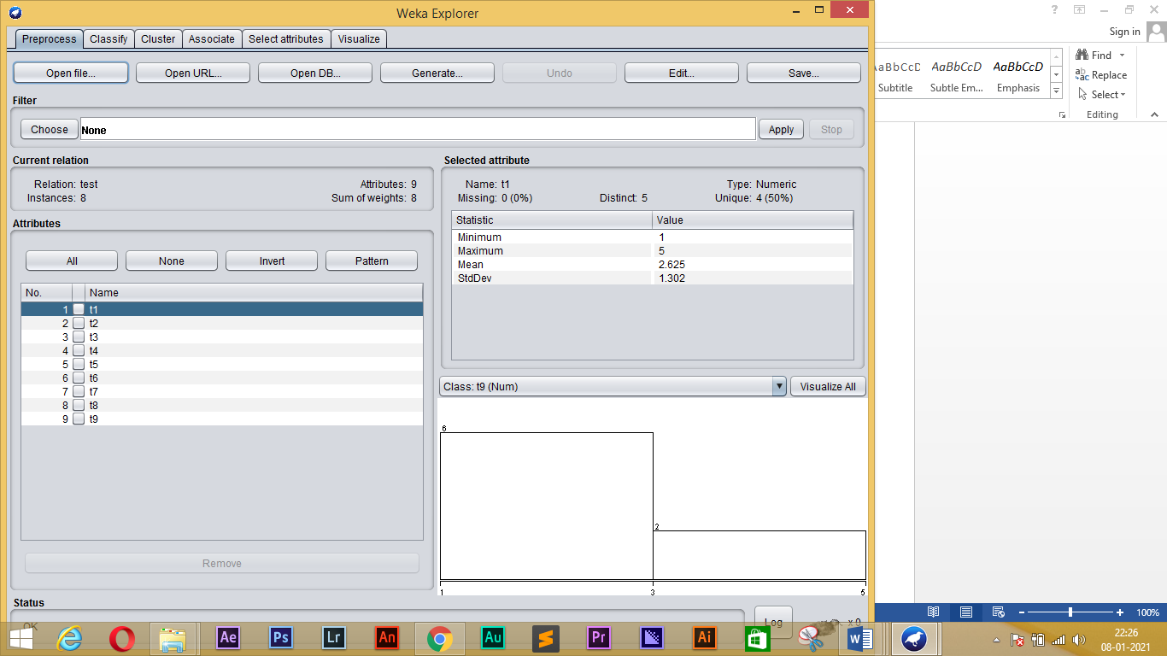

**K-MEANS:**

**K=2:**

=== Run information ===

Scheme: weka.clusterers.SimpleKMeans -init 0 -max-candidates 100 -periodic-pruning 10000 -min-density 2.0 -t1 -1.25 -t2 -1.0 -N 2 -A "weka.core.EuclideanDistance -R first-last" -I 500 -num-slots 1 -S 10

Relation: test

Instances: 8

Attributes: 9

t1

t2

t3

t4

t5

t6

t7

t8

t9

Test mode: evaluate on training data

=== Clustering model (full training set) ===

kMeans

======

Number of iterations: 2

Within cluster sum of squared errors: 5.392129629629629

Initial starting points (random):

Cluster 0: 2,2,3,2,2,2,1,1,5

Cluster 1: 2,2,3,2,2,5,1,1,5

Missing values globally replaced with mean/mode

Final cluster centroids:

Cluster#

Attribute Full Data 0 1

(8.0) (6.0) (2.0)

============================================

t1 2.625 2.3333 3.5

t2 3 3 3

t3 2.5 2 4

t4 2.25 1.8333 3.5

t5 2.75 2.6667 3

t6 2.75 2 5

t7 2.625 2.1667 4

t8 2.875 3 2.5

t9 3 2.3333 5

Time taken to build model (full training data) : 0 seconds

=== Model and evaluation on training set ===

Clustered Instances

0 6 ( 75%)

1 2 ( 25%)

**K=3:**

=== Run information ===

Scheme: weka.clusterers.SimpleKMeans -init 0 -max-candidates 100 -periodic-pruning 10000 -min-density 2.0 -t1 -1.25 -t2 -1.0 -N 3 -A "weka.core.EuclideanDistance -R first-last" -I 500 -num-slots 1 -S 10

Relation: test

Instances: 8

Attributes: 9

t1

t2

t3

t4

t5

t6

t7

t8

t9

Test mode: evaluate on training data

=== Clustering model (full training set) ===

kMeans

======

Number of iterations: 3

Within cluster sum of squared errors: 2.861027777777778

Initial starting points (random):

Cluster 0: 2,2,3,2,2,2,1,1,5

Cluster 1: 2,2,3,2,2,5,1,1,5

Cluster 2: 5,4,5,5,4,5,7,4,5

Missing values globally replaced with mean/mode

Final cluster centroids:

Cluster#

Attribute Full Data 0 1 2

(8.0) (5.0) (2.0) (1.0)

=======================================================

t1 2.625 2.4 2 5

t2 3 3.2 2 4

t3 2.5 1.8 3 5

t4 2.25 1.8 2 5

t5 2.75 2.8 2 4

t6 2.75 2 3.5 5

t7 2.625 2.4 1 7

t8 2.875 3.4 1 4

t9 3 1.8 5 5

Time taken to build model (full training data) : 0 seconds

=== Model and evaluation on training set ===

Clustered Instances

0 5 ( 63%)

1 2 ( 25%)

2 1 ( 13%)

**EM:**

**K=2:**

=== Run information ===

Scheme: weka.clusterers.EM -I 100 -N 2 -X 10 -max -1 -ll-cv 1.0E-6 -ll-iter 1.0E-6 -M 1.0E-6 -K 10 -num-slots 1 -S 100

Relation: test

Instances: 8

Attributes: 9

t1

t2

t3

t4

t5

t6

t7

t8

t9

Test mode: evaluate on training data

=== Clustering model (full training set) ===

EM

==

Number of clusters: 2

Number of iterations performed: 0

Cluster

Attribute 0 1

(0.13) (0.88)

==========================

t1

mean 5 2.2857

std. dev. 0 0.9512

t2

mean 4 2.8571

std. dev. 0 1.3452

t3

mean 5 2.1429

std. dev. 0 0.8997

t4

mean 5 1.8571

std. dev. 0 1.215

t5

mean 4 2.5714

std. dev. 0 0.9759

t6

mean 5 2.4286

std. dev. 0 1.2724

t7

mean 7 2

std. dev. 0 1.1547

t8

mean 4 2.7143

std. dev. 0 1.496

t9

mean 5 2.7143

std. dev. 0 1.6036

Time taken to build model (full training data) : 0 seconds

=== Model and evaluation on training set ===

Clustered Instances

0 1 ( 13%)

1 7 ( 88%)

Log likelihood: 2.14563

**K=3:**

=== Run information ===

Scheme: weka.clusterers.EM -I 100 -N 3 -X 10 -max -1 -ll-cv 1.0E-6 -ll-iter 1.0E-6 -M 1.0E-6 -K 10 -num-slots 1 -S 100

Relation: test

Instances: 8

Attributes: 9

t1

t2

t3

t4

t5

t6

t7

t8

t9

Test mode: evaluate on training data

=== Clustering model (full training set) ===

EM

==

Number of clusters: 3

Number of iterations performed: 0

Cluster

Attribute 0 1 2

(0.13) (0.38) (0.5)

=================================

t1

mean 5 2 2.5

std. dev. 0 1.3025 1.291

t2

mean 4 1.6667 3.75

std. dev. 0 0.5774 0.9574

t3

mean 5 2.6667 1.75

std. dev. 0 0.5774 0.9574

t4

mean 5 2 1.75

std. dev. 0 1.5811 1.7078

t5

mean 4 1.6667 3.25

std. dev. 0 0.5774 0.5

t6

mean 5 3 2

std. dev. 0 1.7321 0.8165

t7

mean 7 1.3333 2.5

std. dev. 0 0.5774 1.291

t8

mean 4 1.3333 3.75

std. dev. 0 0.5774 0.9574

t9

mean 5 4 1.75

std. dev. 0 1.7321 0.5

Time taken to build model (full training data) : 0.01 seconds

=== Model and evaluation on training set ===

Clustered Instances

0 1 ( 13%)

1 3 ( 38%)

2 4 ( 50%)

Log likelihood: 4.41901

**Cobweb algorithm:**

**1, LOAD THE IRIS DATASET:**

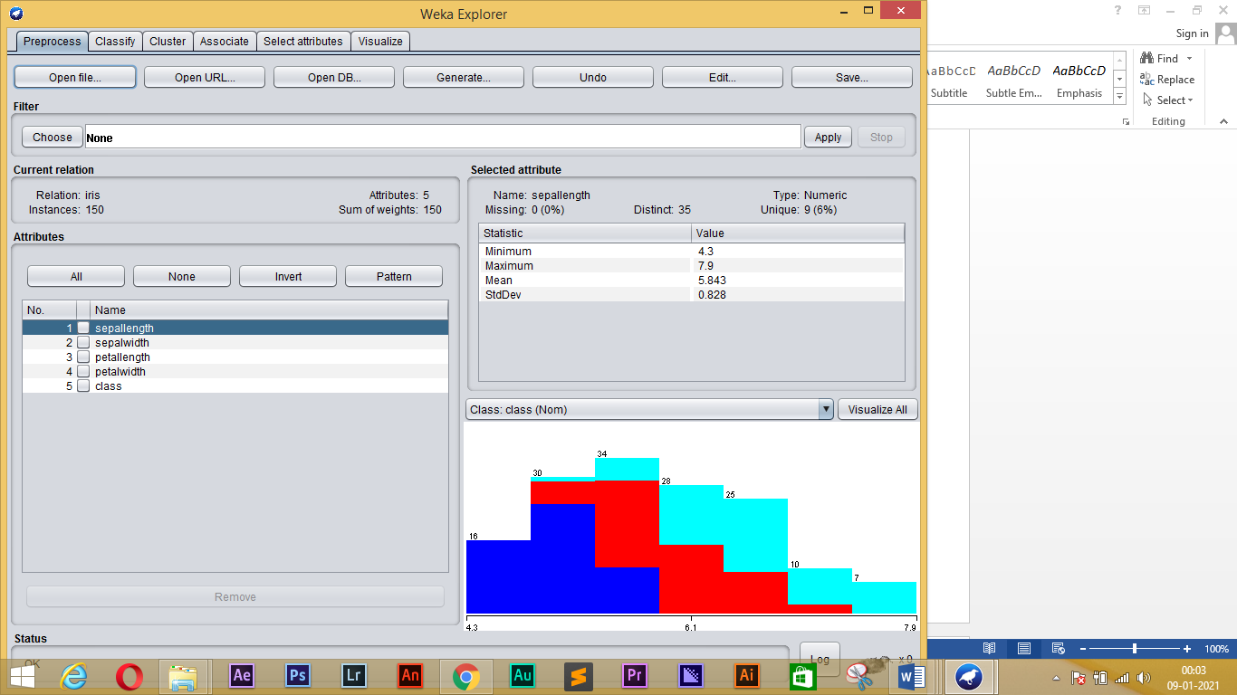

**2, Use cobweb algorithm on training set and Visualize Tree:**

=== Run information ===

Scheme: weka.clusterers.Cobweb -A 1.0 -C 0.0028209479177387815 -S 42

Relation: iris

Instances: 150

Attributes: 5

sepallength

sepalwidth

petallength

petalwidth

Ignored:

class

Test mode: evaluate on training data

=== Clustering model (full training set) ===

Number of merges: 0

Number of splits: 0

Number of clusters: 3

node 0 [150]

| leaf 1 [97]

node 0 [150]

| leaf 2 [53]

Time taken to build model (full training data) : 0.03 seconds

=== Model and evaluation on training set ===

Clustered Instances

1 100 ( 67%)

2 50 ( 33%)

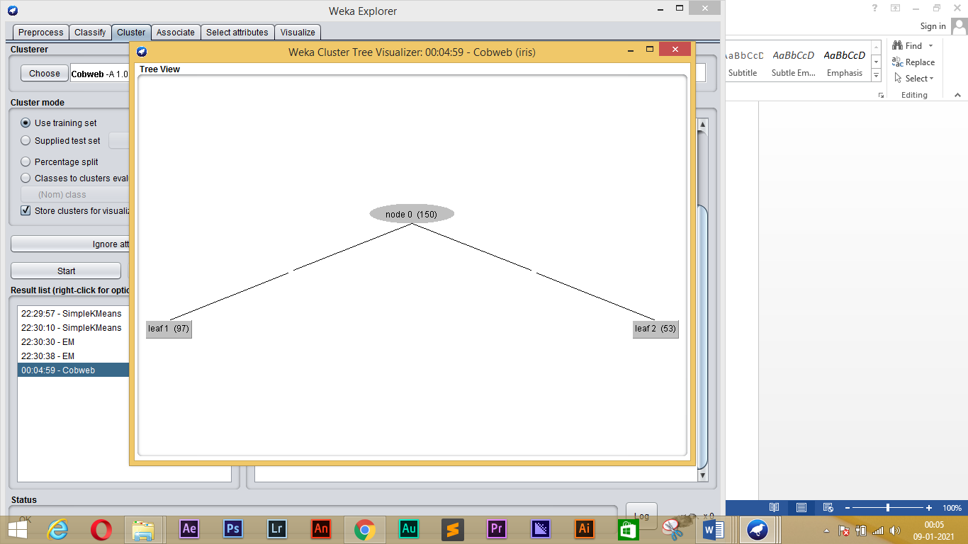

**3, Use cobweb algorithm on classes to cluster evaluation and Visualize Tree:**

=== Run information ===

Scheme: weka.clusterers.Cobweb -A 1.0 -C 0.0028209479177387815 -S 42

Relation: iris

Instances: 150

Attributes: 5

sepallength

sepalwidth

petallength

petalwidth

Ignored:

class

Test mode: Classes to clusters evaluation on training data

=== Clustering model (full training set) ===

Number of merges: 0

Number of splits: 0

Number of clusters: 3

node 0 [150]

| leaf 1 [97]

node 0 [150]

| leaf 2 [53]

Time taken to build model (full training data) : 0.01 seconds

=== Model and evaluation on training set ===

Clustered Instances

1 100 ( 67%)

2 50 ( 33%)

Class attribute: class

Classes to Clusters:

1 2 <-- assigned to cluster

0 50 | Iris-setosa

50 0 | Iris-versicolor

50 0 | Iris-virginica

Cluster 1 <-- Iris-versicolor

Cluster 2 <-- Iris-setosa

Incorrectly clustered instances : 50.0 33.3333 %

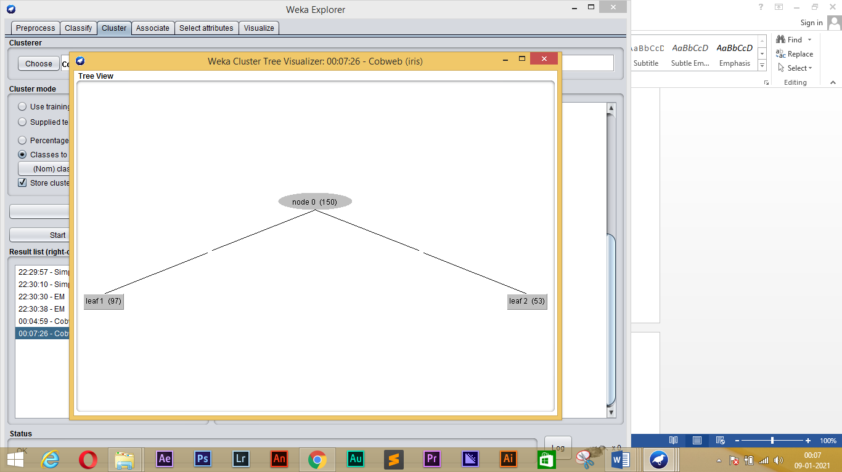

**RESULT:**

Clustering using WEKA Tool is performed.

**EXPERIMENT-6**

**Aim**:

To perform Association Rule Analysis using WEKA Tool.

**Procedure**:

1. Implement the Apriori algorithm. Your implementation should allow the user to specify a minimum support threshold (*minsup*), a minimum confidence threshold (*minconf*), and a maximum number of rules to display at a time (*maxrules*).
2. Use your algorithm on the Binarized Lenses problem.
   * Run Apriori for 0.1 <= *minsup* <= 0.8 and 0.1 <= *minconf* <= 0.6, using increments of 0.1 (i.e., this means you should run the algorithm 48 times).
   * Summarize your findings.
   * Given this additional information about the data, what do your (discovered) associations tell us?
3. Use your algorithm on the Mirror Symmetry problem.
   * Run Apriori for various combinations of *minsup* and *minconf* values.
   * Summarize your findings.
   * This is an artificial problem. Each attribute represents a bit position in a string of 30 bits: *Lmost, Lmost1, ..., Lmost14, Rmost14, Rmost13, ..., Rmost1, Rmost* and the attribute *Symm* is 1 if the pattern is symmetric about its center, and 0 otherwise. Given this interpretation, do any of the rules discovered by your Apriori algorithm make sense?
4. Build your own association task.
   * Design your task so that it contains some simple associations you can check your algorithm against. List these associations.
   * Run Apriori for various combinations of *minsup* and *minconf* values.
   * Verify that the associations you designed into the task are discovered by your algorithm.
   * Are there any surprises?

**OUTPUT:**

**1,Binarized Lenses problem**

**0.1 <= *minsup*<= 0.8 and 0.1 <= *minconf*<= 0.6**

=== Run information ===

Scheme: weka.associations.Apriori -N 10 -T 0 -C 0.1 -D 0.05 -U 0.8 -M 0.1 -S -1.0 -c -1

Relation: contact-lenses

Instances: 24

Attributes: 7

young

pre-presbyopic

presbyopic

hypermetrope

astigmatism

norm-tearp-rate

no-lenses

=== Associator model (full training set) ===

Apriori

=======

Minimum support: 0.35 (8 instances)

Minimum metric <confidence>: 0.1

Number of cycles performed: 13

Generated sets of large itemsets:

Size of set of large itemsets L(1): 14

Size of set of large itemsets L(2): 34

Size of set of large itemsets L(3): 6

Best rules found:

1. norm-tearp-rate=0 12 ==> no-lenses=1 12 <conf:(1)> lift:(1.6) lev:(0.19) [4] conv:(4.5)

2. no-lenses=0 9 ==> norm-tearp-rate=1 9 <conf:(1)> lift:(2) lev:(0.19) [4] conv:(4.5)

3. pre-presbyopic=1 8 ==> young=0 8 <conf:(1)> lift:(1.5) lev:(0.11) [2] conv:(2.67)

4. presbyopic=1 8 ==> young=0 8 <conf:(1)> lift:(1.5) lev:(0.11) [2] conv:(2.67)

5. young=1 8 ==> pre-presbyopic=0 8 <conf:(1)> lift:(1.5) lev:(0.11) [2] conv:(2.67)

6. young=1 8 ==> presbyopic=0 8 <conf:(1)> lift:(1.5) lev:(0.11) [2] conv:(2.67)

7. presbyopic=1 8 ==> pre-presbyopic=0 8 <conf:(1)> lift:(1.5) lev:(0.11) [2] conv:(2.67)

8. pre-presbyopic=1 8 ==> presbyopic=0 8 <conf:(1)> lift:(1.5) lev:(0.11) [2] conv:(2.67)

9. pre-presbyopic=0 presbyopic=1 8 ==> young=0 8 <conf:(1)> lift:(1.5) lev:(0.11) [2] conv:(2.67)

10. young=0 presbyopic=1 8 ==> pre-presbyopic=0 8 <conf:(1)> lift:(1.5) lev:(0.11) [2] conv:(2.67)

**2, Mirror Symmetry problem**

=== Run information ===

Scheme: weka.associations.Apriori -N 10 -T 0 -C 0.1 -D 0.05 -U 0.8 -M 0.1 -S -1.0 -c -1

Relation: contact-lenses

Instances: 24

Attributes: 5

age

spectacle-prescrip

astigmatism

tear-prod-rate

contact-lenses

=== Associator model (full training set) ===

Apriori

=======

Minimum support: 0.3 (7 instances)

Minimum metric <confidence>: 0.1

Number of cycles performed: 14

Generated sets of large itemsets:

Size of set of large itemsets L(1): 10

Size of set of large itemsets L(2): 5

Best rules found:

1. tear-prod-rate=reduced 12 ==> contact-lenses=none 12 <conf:(1)> lift:(1.6) lev:(0.19) [4] conv:(4.5)

2. contact-lenses=none 15 ==> tear-prod-rate=reduced 12 <conf:(0.8)> lift:(1.6) lev:(0.19) [4] conv:(1.88)

3. spectacle-prescrip=hypermetrope 12 ==> contact-lenses=none 8 <conf:(0.67)> lift:(1.07) lev:(0.02) [0] conv:(0.9)

4. astigmatism=yes 12 ==> contact-lenses=none 8 <conf:(0.67)> lift:(1.07) lev:(0.02) [0] conv:(0.9)

5. spectacle-prescrip=myope 12 ==> contact-lenses=none 7 <conf:(0.58)> lift:(0.93) lev:(-0.02) [0] conv:(0.75)

6. astigmatism=no 12 ==> contact-lenses=none 7 <conf:(0.58)> lift:(0.93) lev:(-0.02) [0] conv:(0.75)

7. contact-lenses=none 15 ==> spectacle-prescrip=hypermetrope 8 <conf:(0.53)> lift:(1.07) lev:(0.02) [0] conv:(0.94)

8. contact-lenses=none 15 ==> astigmatism=yes 8 <conf:(0.53)> lift:(1.07) lev:(0.02) [0] conv:(0.94)

9. contact-lenses=none 15 ==> spectacle-prescrip=myope 7 <conf:(0.47)> lift:(0.93) lev:(-0.02) [0] conv:(0.83)

10. contact-lenses=none 15 ==> astigmatism=no 7 <conf:(0.47)> lift:(0.93) lev:(-0.02) [0] conv:(0.83)

Transactional database:

Min=0.5

=== Run information ===

Scheme: weka.associations.Apriori -N 10 -T 0 -C 10.0 -D 0.05 -U 30.0 -M 0.0 -S -1.0 -c -1

Relation: contact-lenses

Instances: 24

Attributes: 5

age

spectacle-prescrip

astigmatism

tear-prod-rate

contact-lenses

=== Associator model (full training set) ===

Apriori

=======

Minimum support: 0.04 (1 instances)

Minimum metric <confidence>: 10

Number of cycles performed: 600

Generated sets of large itemsets:

Size of set of large itemsets L(1): 12

Size of set of large itemsets L(2): 53

Size of set of large itemsets L(3): 104

Size of set of large itemsets L(4): 88

Size of set of large itemsets L(5): 24

Best rules found:

Min=0.8

=== Run information ===

Scheme: weka.associations.Apriori -N 20 -T 0 -C 0.5 -D 0.05 -U 10.0 -M 0.0 -S -1.0 -c -1

Relation: contact-lenses

Instances: 24

Attributes: 5

age

spectacle-prescrip

astigmatism

tear-prod-rate

contact-lenses

=== Associator model (full training set) ===

Apriori

=======

Minimum support: 0.25 (6 instances)

Minimum metric <confidence>: 0.5

Number of cycles performed: 195

Generated sets of large itemsets:

Size of set of large itemsets L(1): 10

Size of set of large itemsets L(2): 18

Size of set of large itemsets L(3): 4

Best rules found:

1. tear-prod-rate=reduced 12 ==> contact-lenses=none 12 conf:(1)

2. spectacle-prescrip=myope tear-prod-rate=reduced 6 ==> contact-lenses=none 6 conf:(1)

3. spectacle-prescrip=hypermetrope tear-prod-rate=reduced 6 ==> contact-lenses=none 6 conf:(1)

4. astigmatism=no tear-prod-rate=reduced 6 ==> contact-lenses=none 6 conf:(1)

5. astigmatism=yes tear-prod-rate=reduced 6 ==> contact-lenses=none 6 conf:(1)

6. spectacle-prescrip=myope contact-lenses=none 7 ==> tear-prod-rate=reduced 6 conf:(0.86)

7. astigmatism=no contact-lenses=none 7 ==> tear-prod-rate=reduced 6 conf:(0.86)

8. contact-lenses=none 15 ==> tear-prod-rate=reduced 12 conf:(0.8)

9. age=presbyopic 8 ==> contact-lenses=none 6 conf:(0.75)

10. spectacle-prescrip=hypermetrope contact-lenses=none 8 ==> tear-prod-rate=reduced 6 conf:(0.75)

11. astigmatism=yes contact-lenses=none 8 ==> tear-prod-rate=reduced 6 conf:(0.75)

12. spectacle-prescrip=hypermetrope 12 ==> contact-lenses=none 8 conf:(0.67)

13. astigmatism=yes 12 ==> contact-lenses=none 8 conf:(0.67)

14. spectacle-prescrip=myope 12 ==> contact-lenses=none 7 conf:(0.58)

15. astigmatism=no 12 ==> contact-lenses=none 7 conf:(0.58)

16. contact-lenses=none 15 ==> spectacle-prescrip=hypermetrope 8 conf:(0.53)

17. contact-lenses=none 15 ==> astigmatism=yes 8 conf:(0.53)

18. astigmatism=no 12 ==> spectacle-prescrip=myope 6 conf:(0.5)

19. spectacle-prescrip=myope 12 ==> astigmatism=no 6 conf:(0.5)

20. astigmatism=yes 12 ==> spectacle-prescrip=myope 6 conf:(0.5)

**RESULT:**

Association Rule Analysis is performed using WEKA tool.